1) Clone the app locally

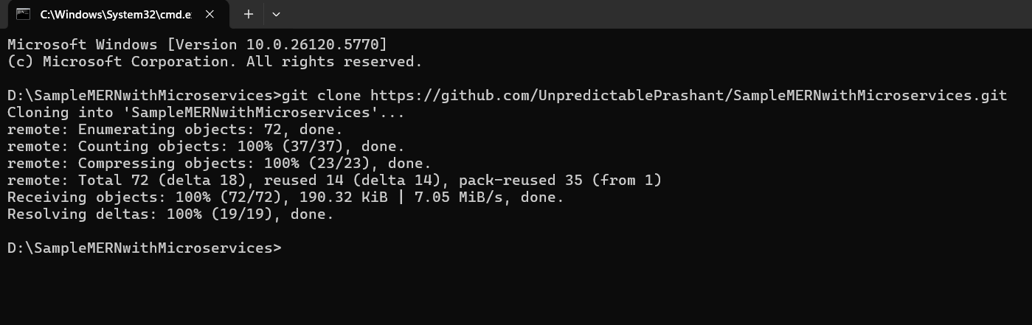

2) **Create Dockerfiles:**

**Backend/helloService/Dockerfile:**

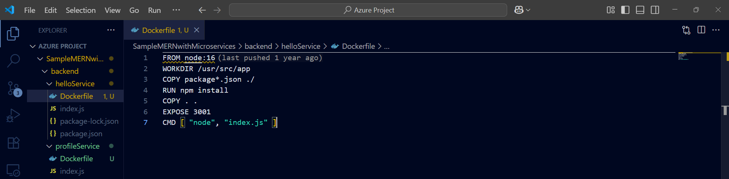

**Backend/profileService/Dockerfile:**

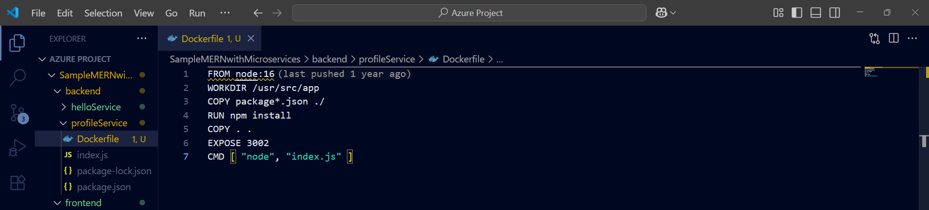

**frontend/Dockerfile:**

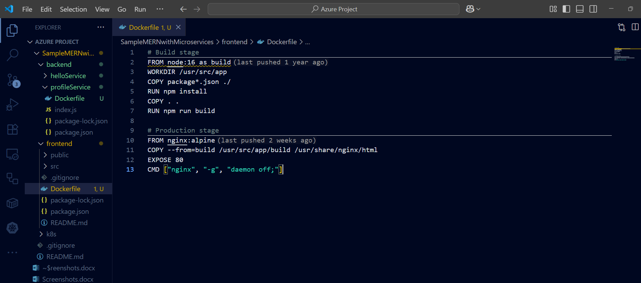

**Step 3: Log in to Docker Hub**

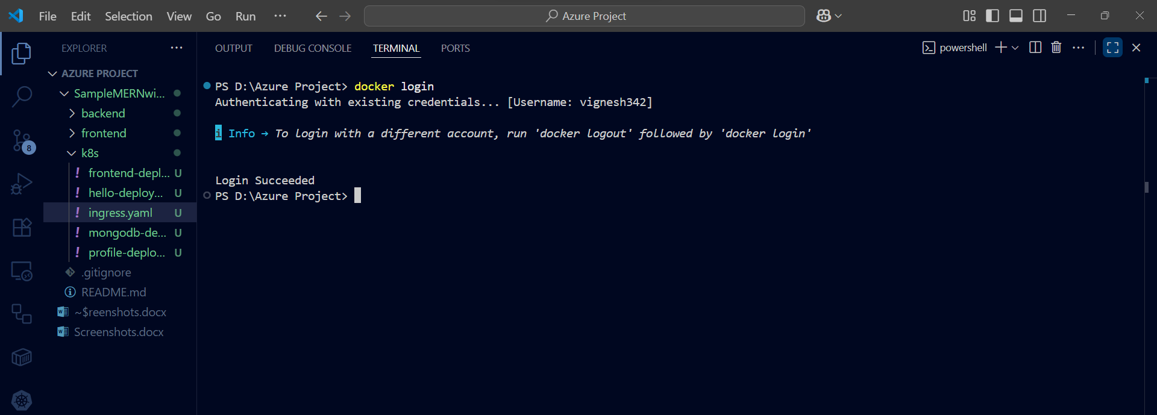

**Step 4: Build & Tag Docker Images**

**helloService:**

**docker build -t vignesh342/hello-service:v1 .**

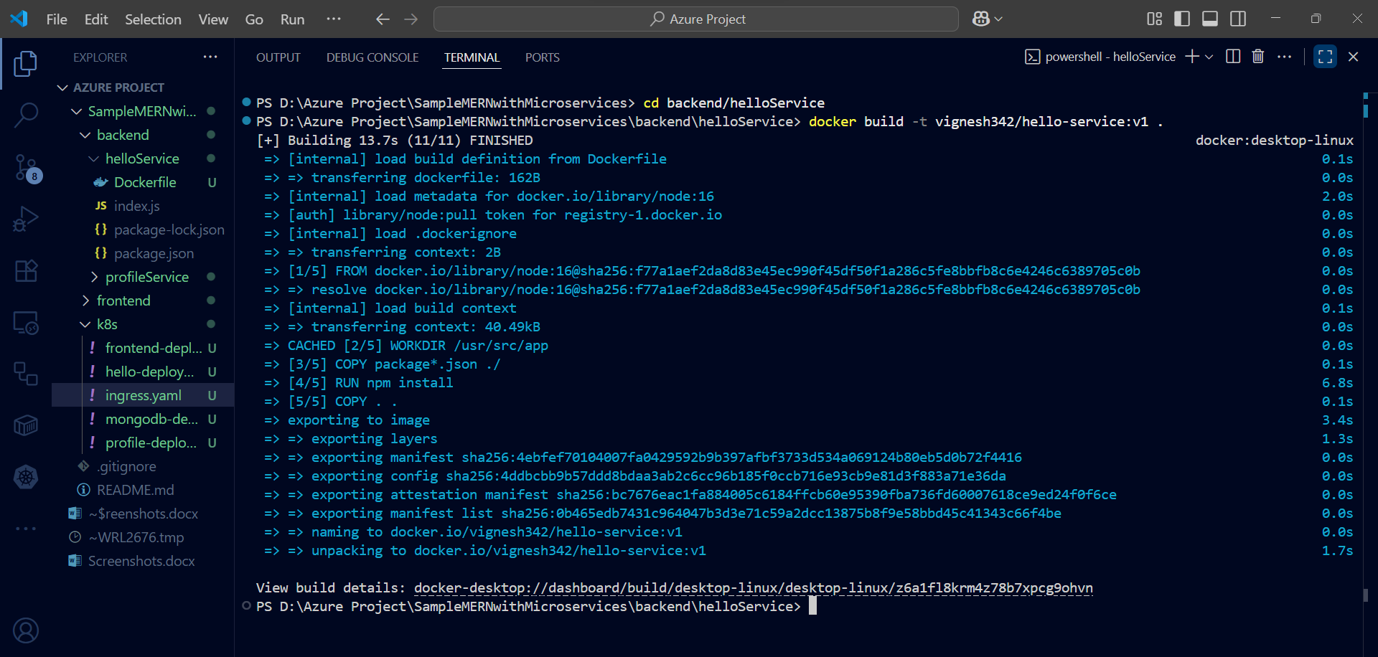

**docker push vignesh342/hello-service:v1**

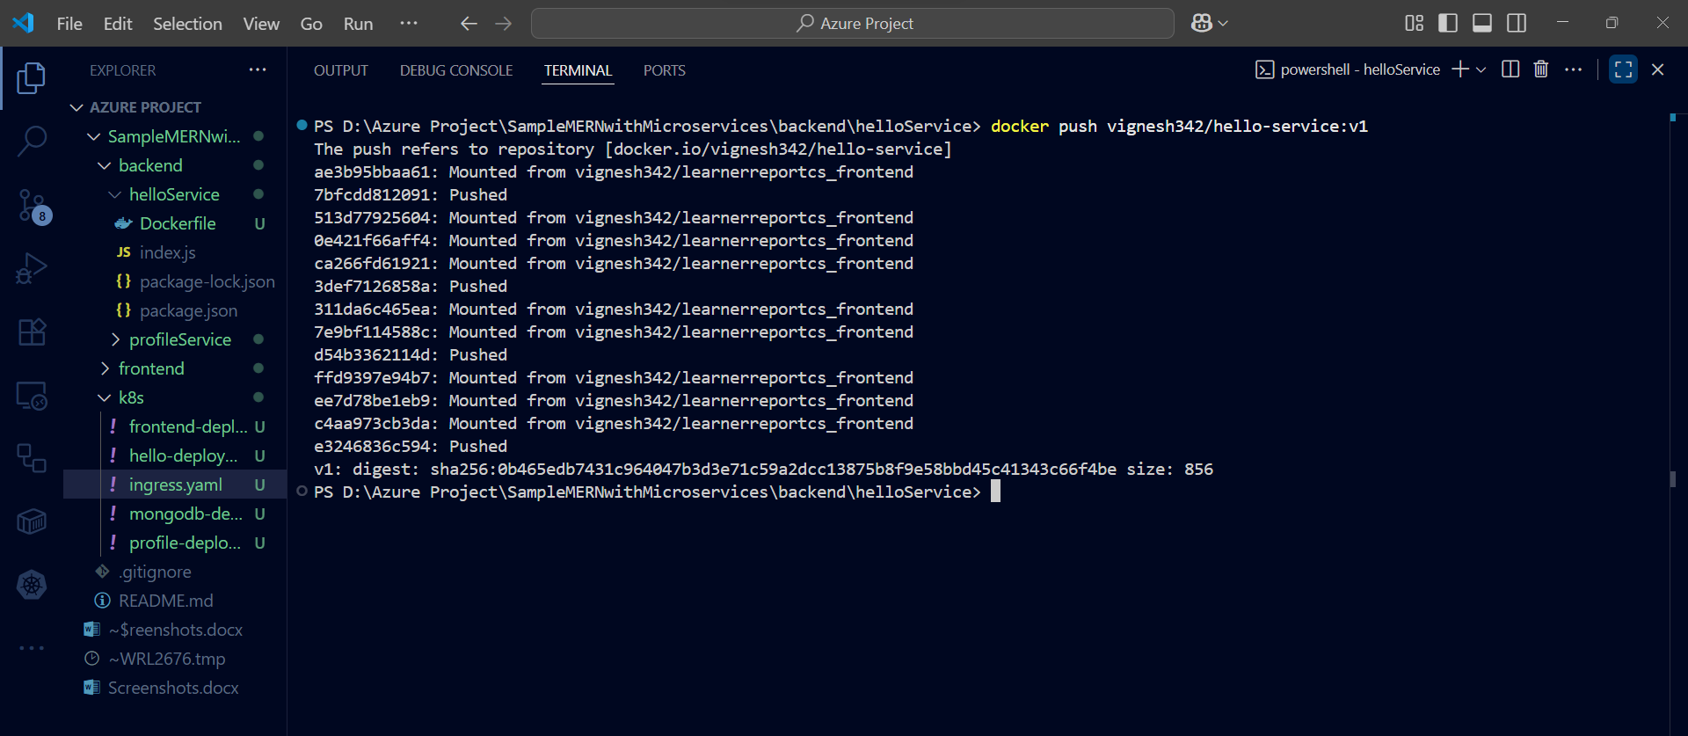

**Profileservice:**

**docker build -t vignesh342/profile-service:v1 .**

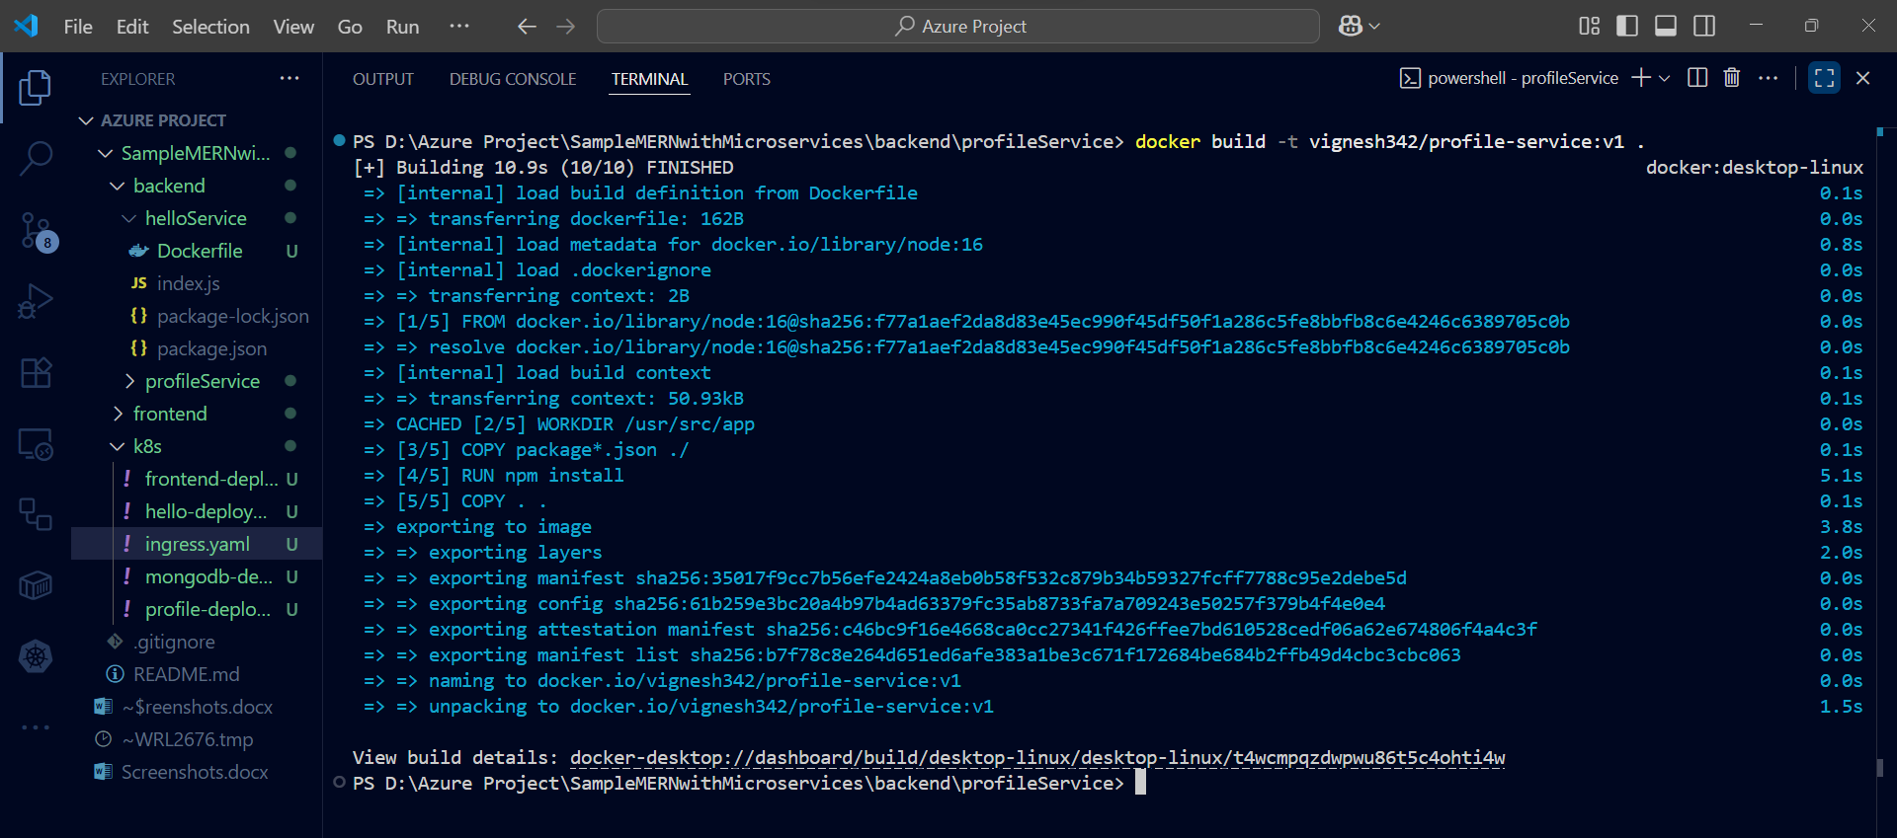

**docker push vignesh342/profile-service:v1**

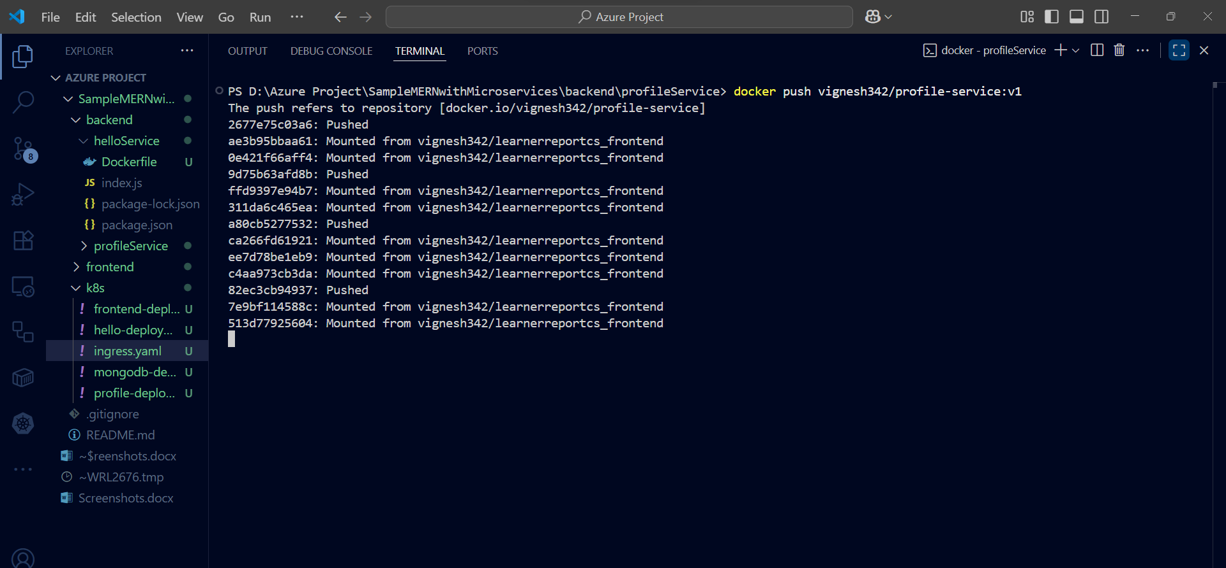

**Frontend:**

**docker build -t vignesh342/frontend-service:v1 .**

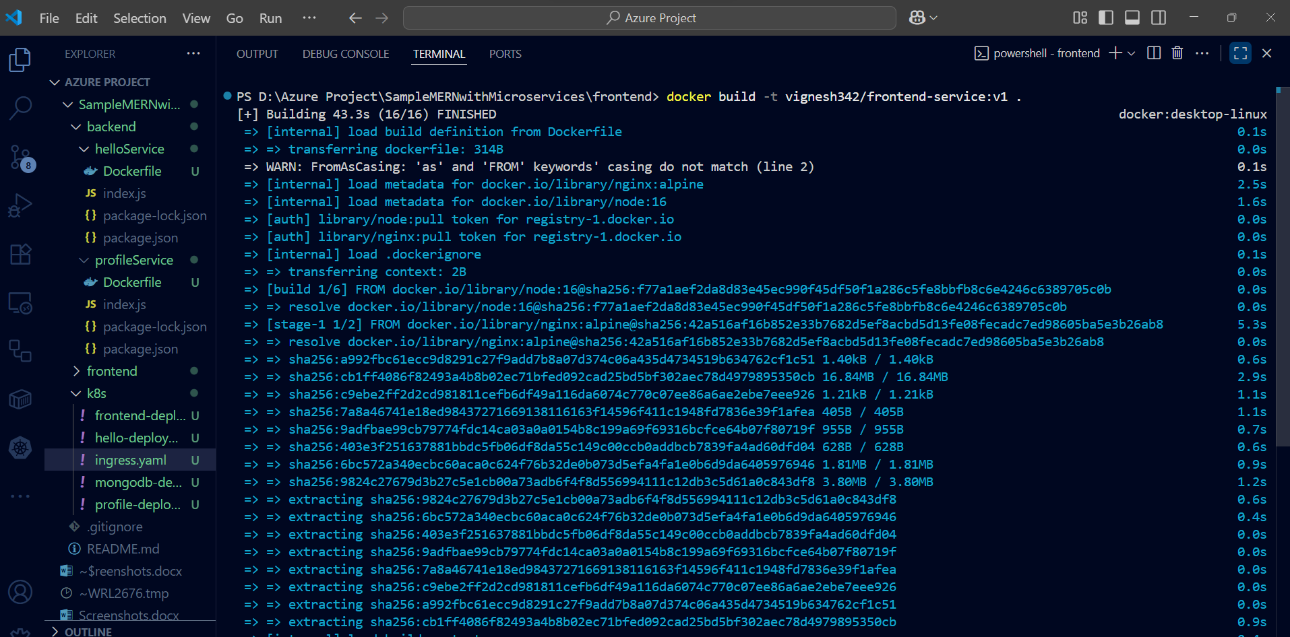

**docker push vignesh342/frontend-service:v1**

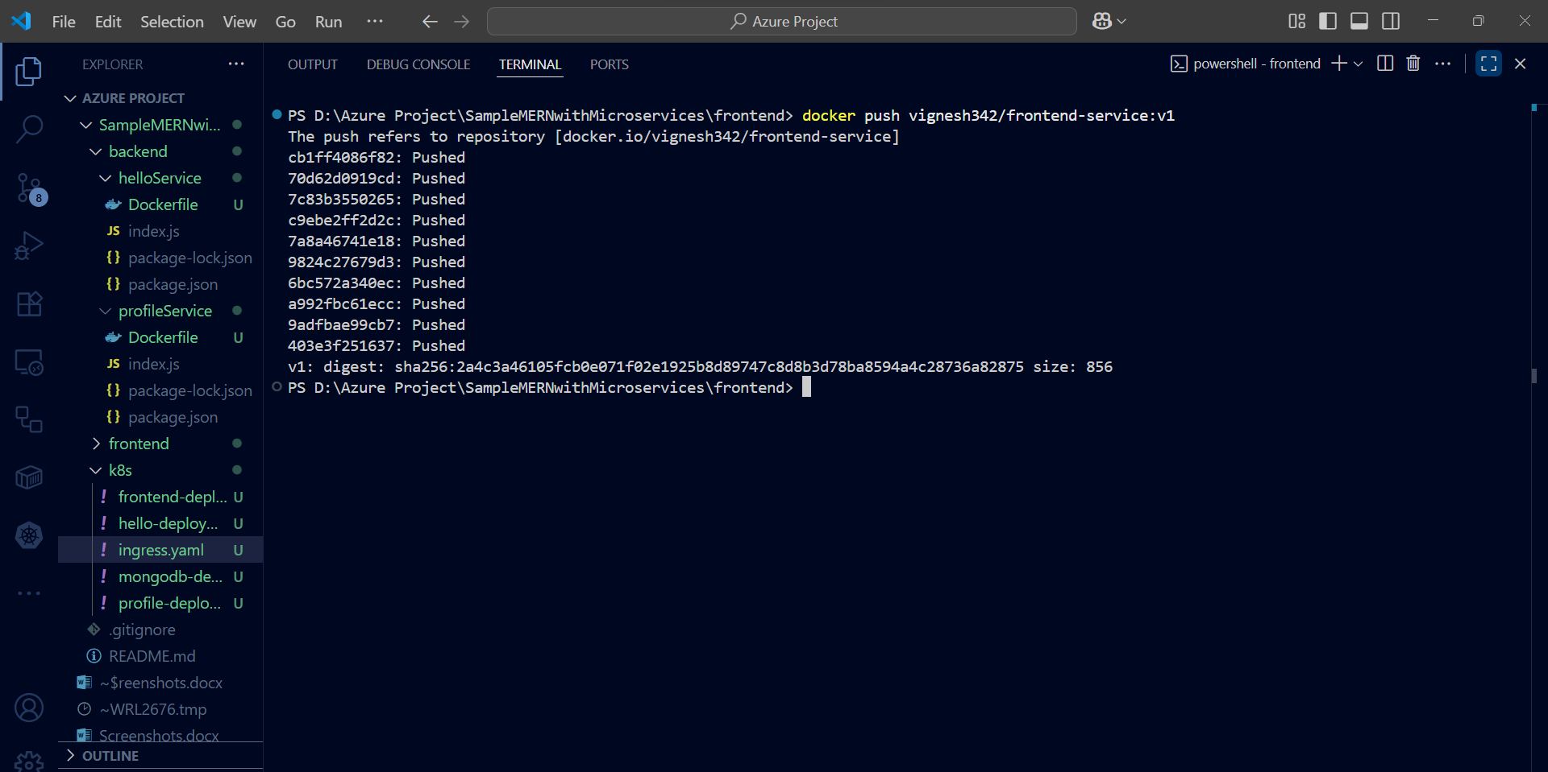

**Docker Hub:**

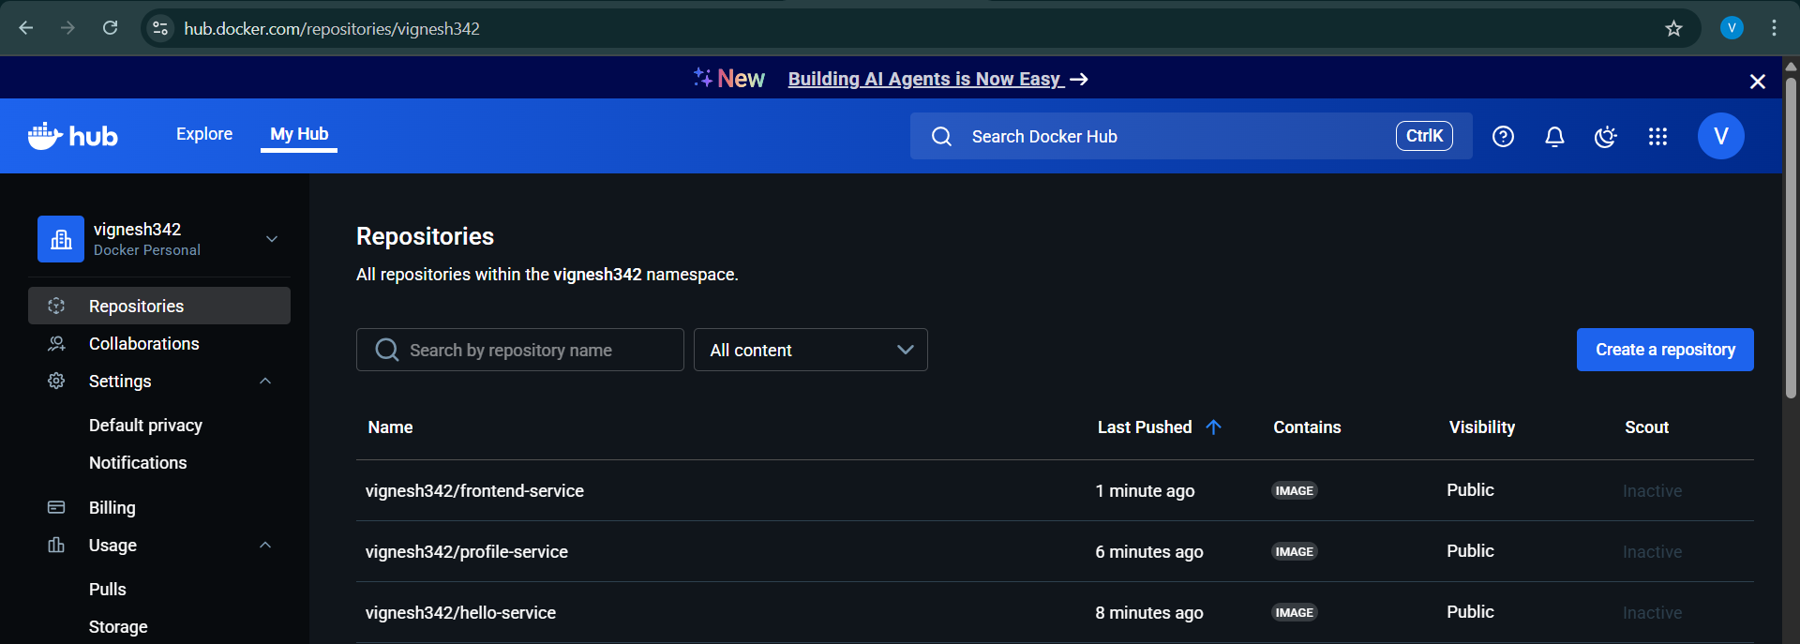

**k8s-manifests:**

**hello-deployment.yaml:**

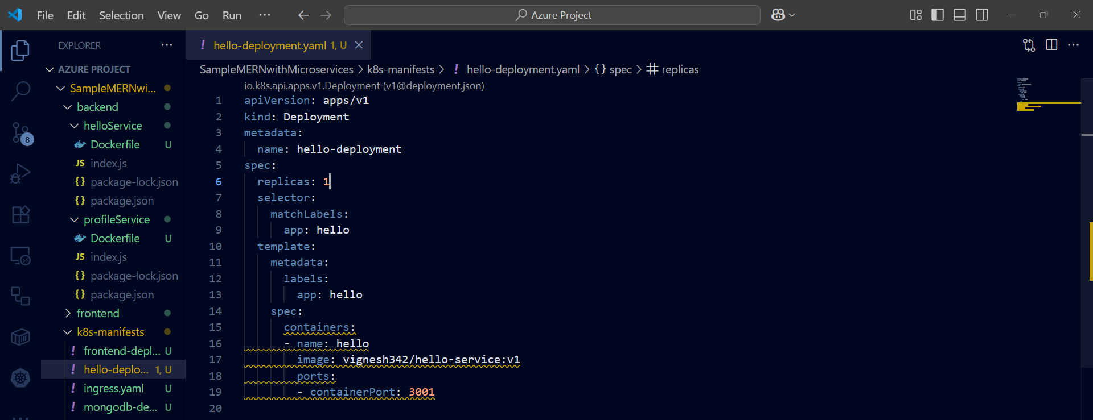

**hello-service.yaml**

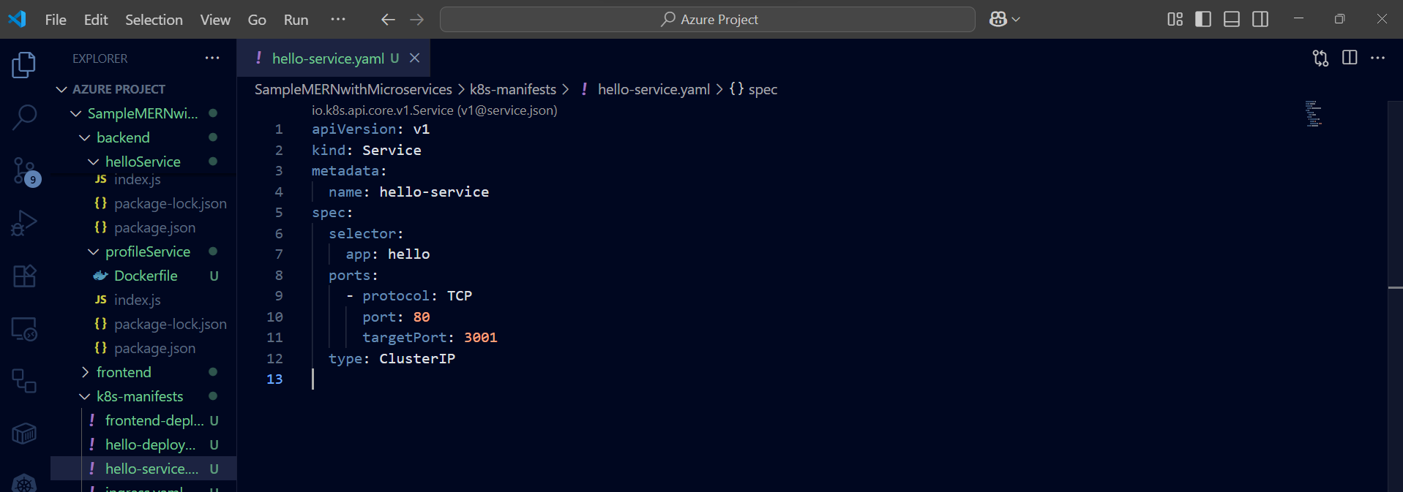

**profile-deployment.yaml:**

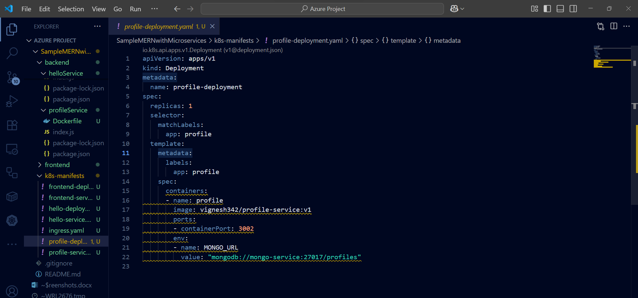

**profile-service.yaml**

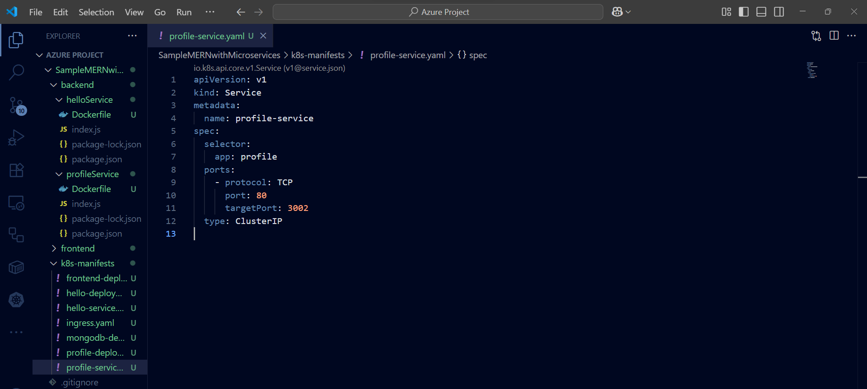

**frontend-deployment.yaml**

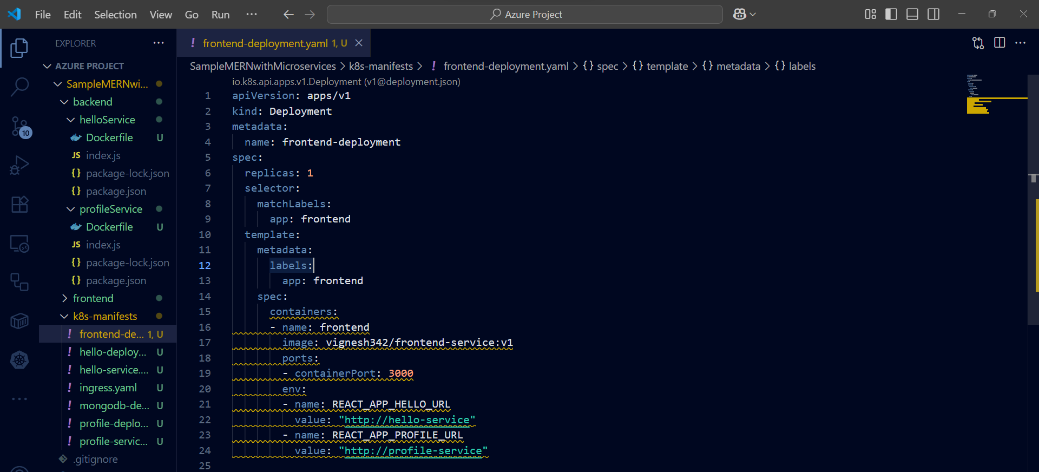

**frontend-service.yaml:**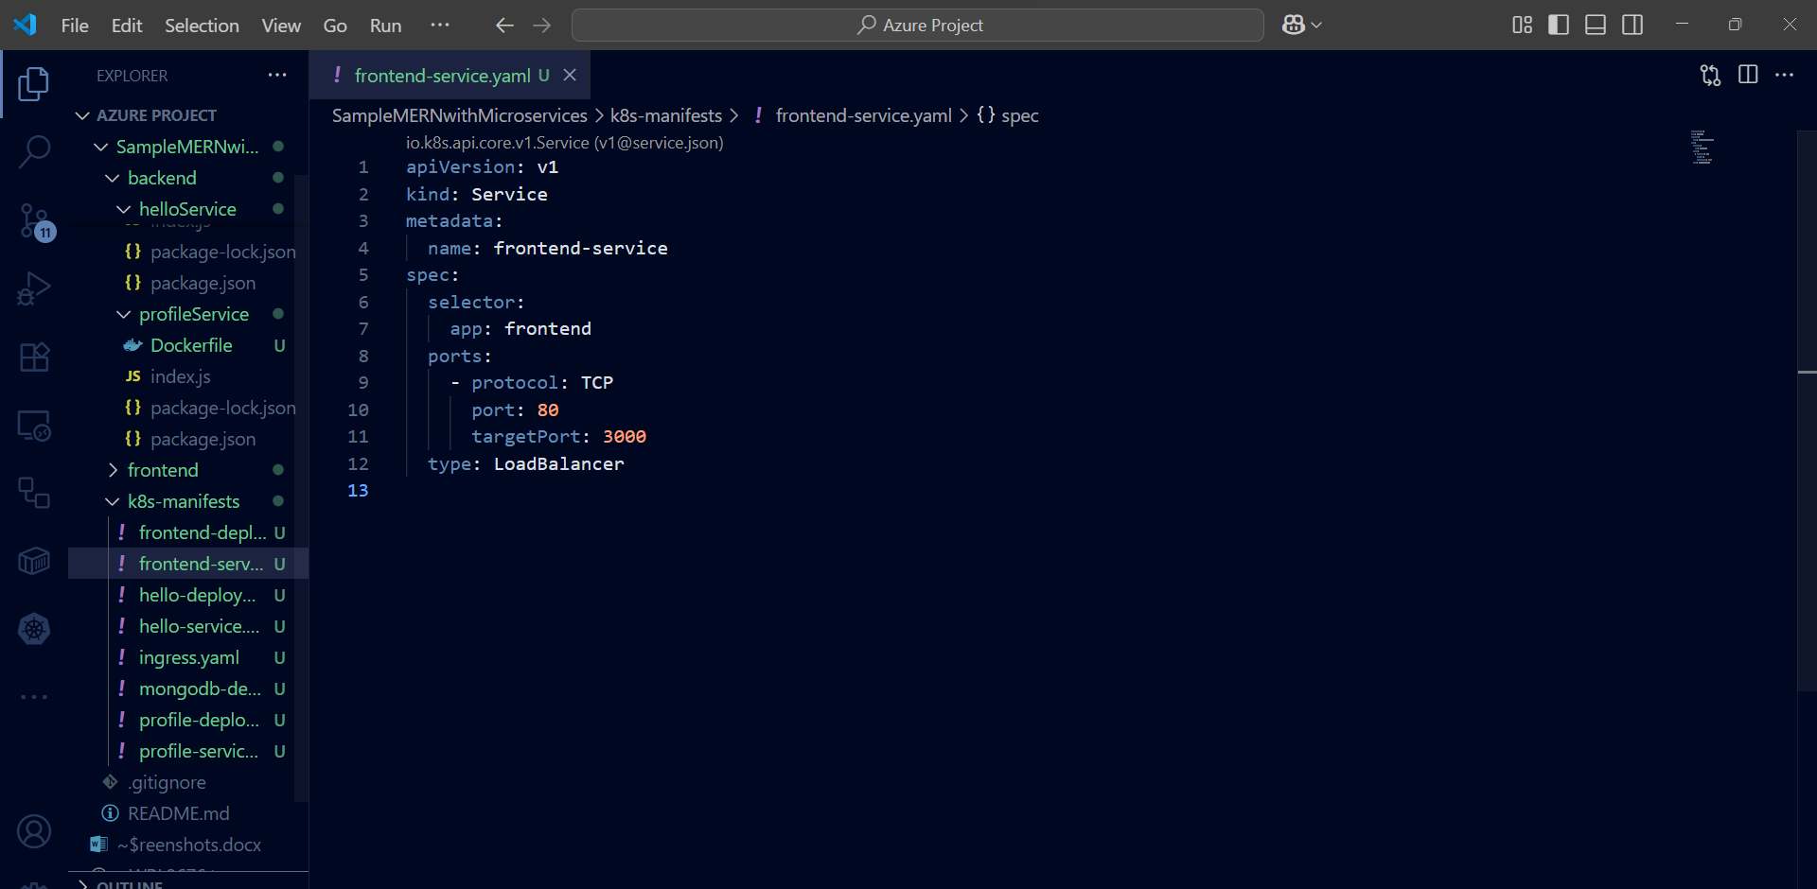

**ingress.yaml:**

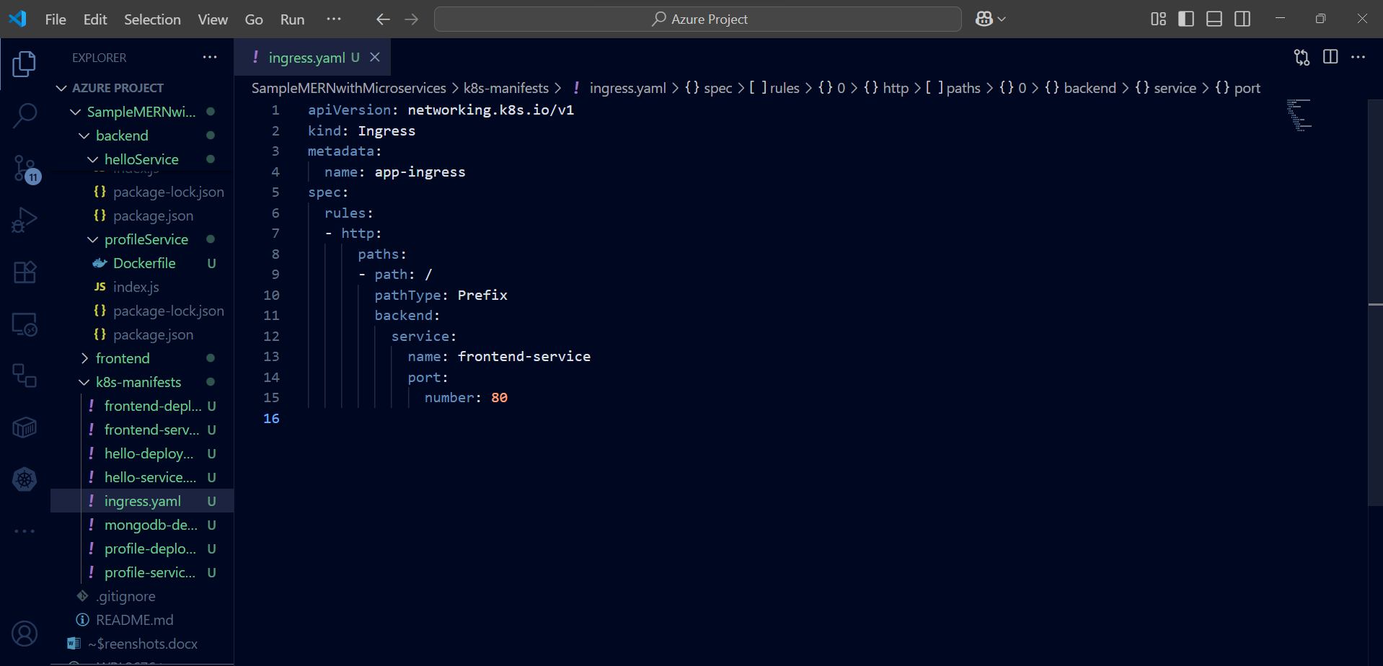

**mongo-deployment.yaml:**

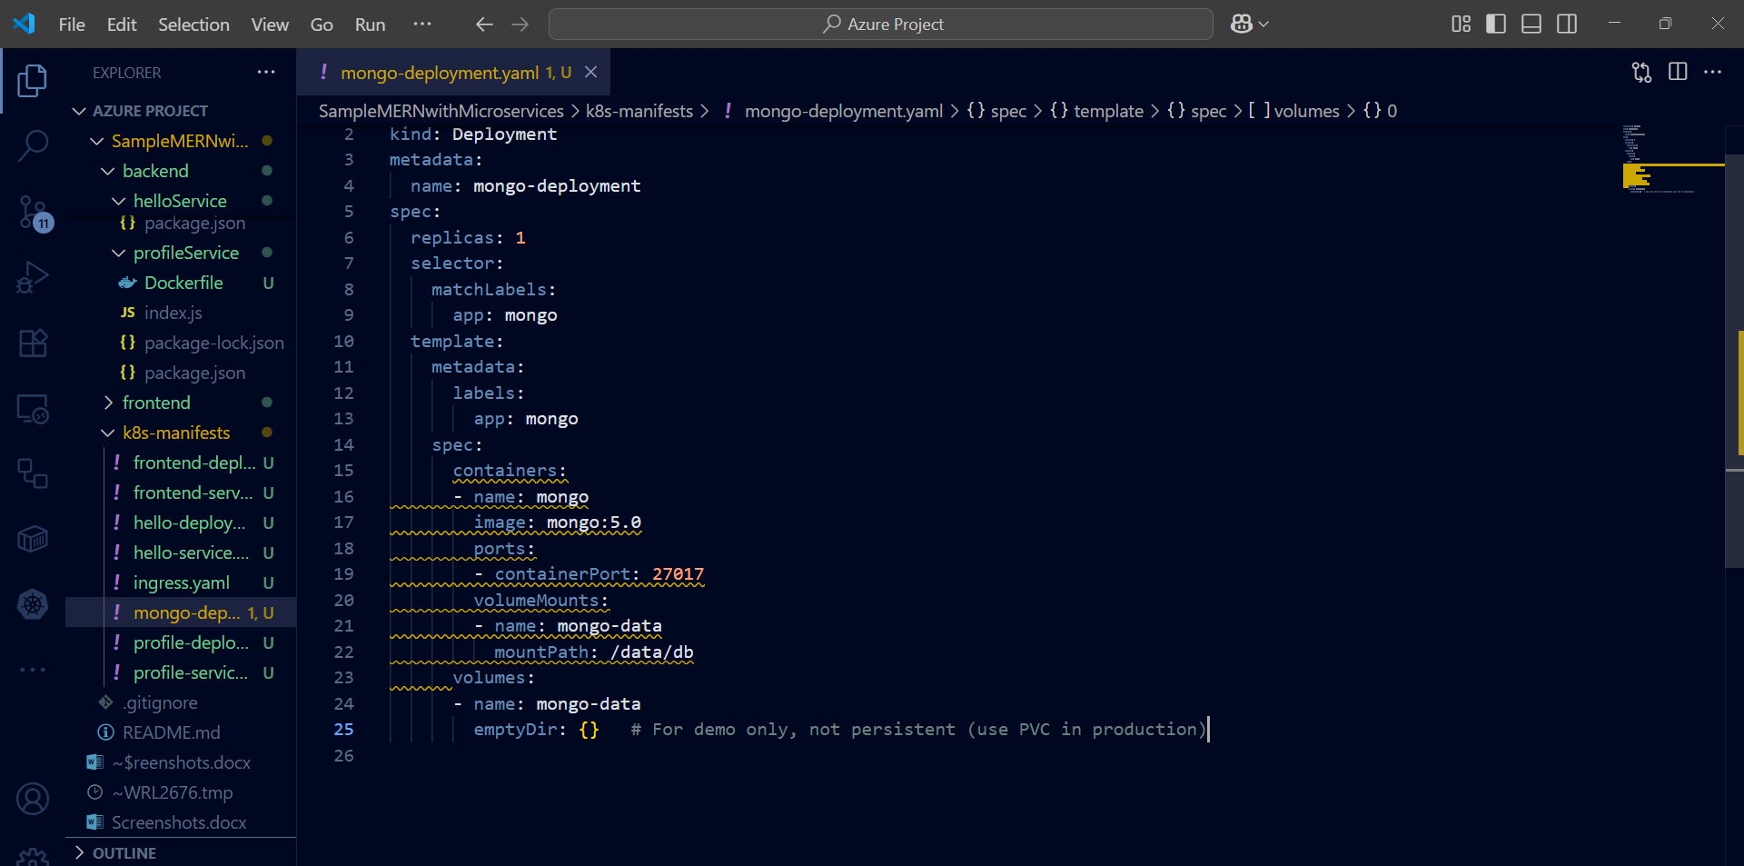

**mongo-service.yaml:**

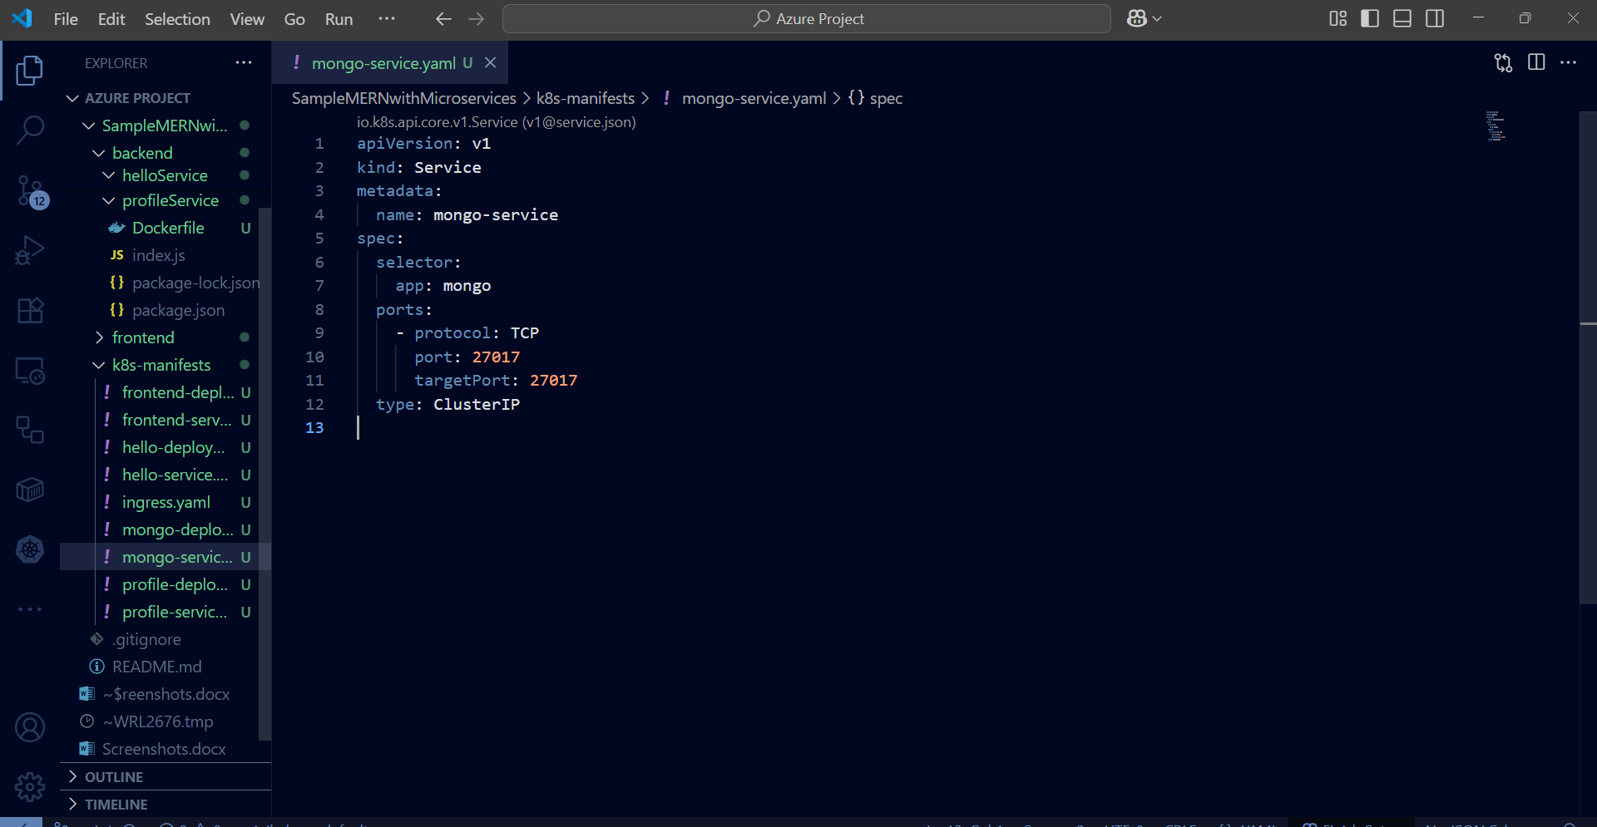

**Steps to Deploy Locally (Docker Desktop Kubernetes or Minikube):**

**Start Minikube:**

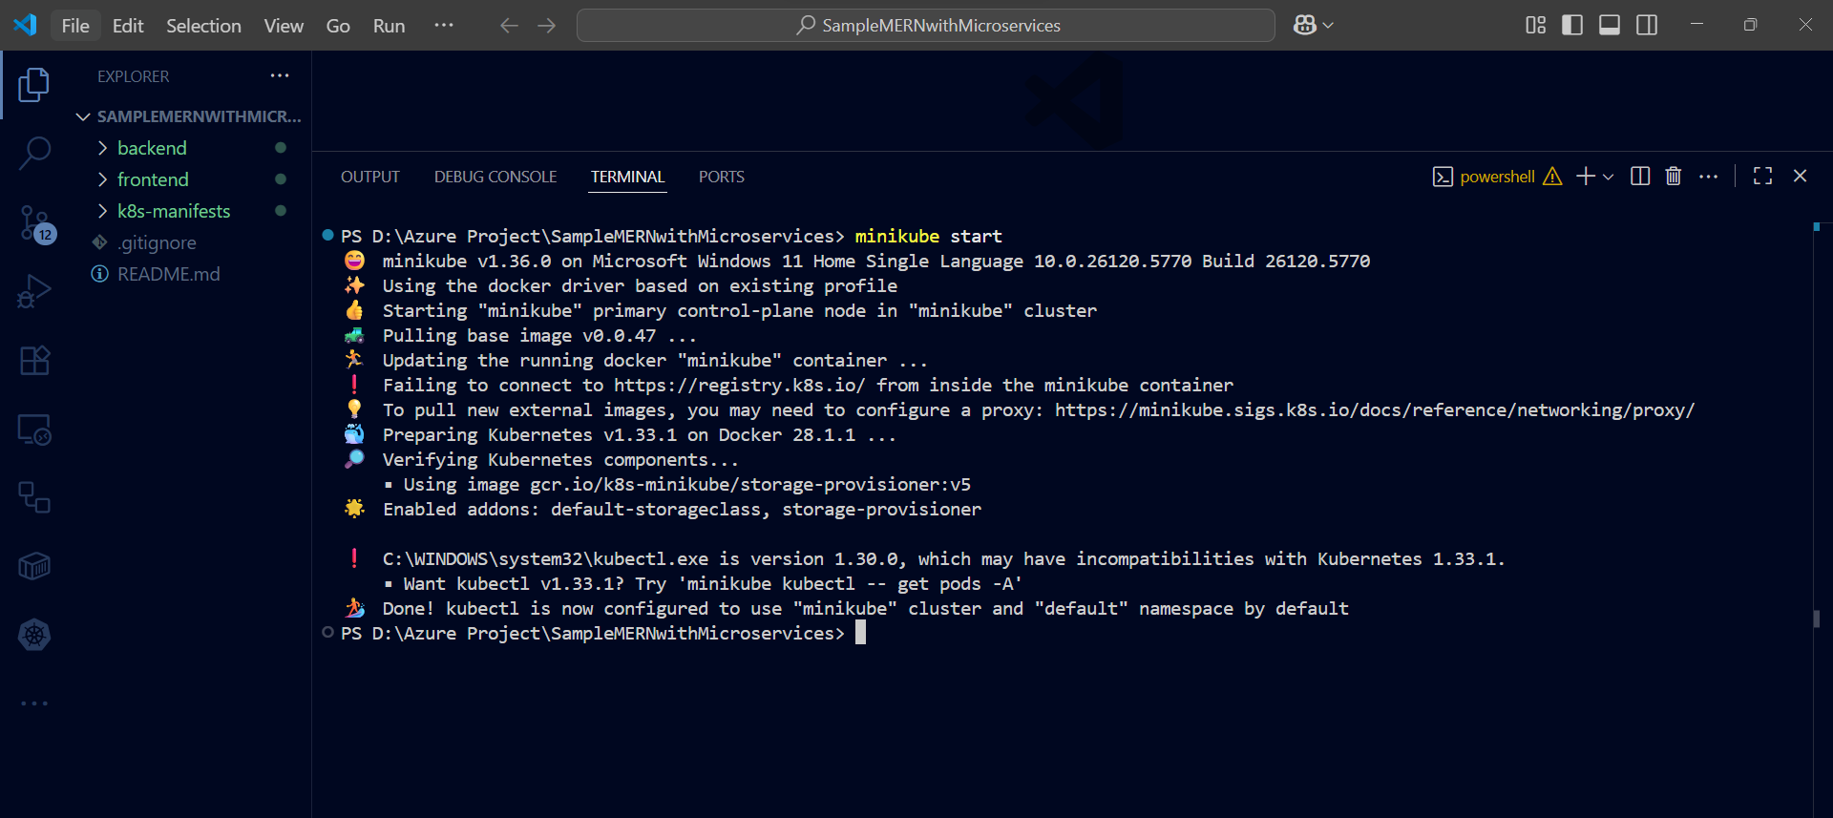

**Verify cluster is running:**

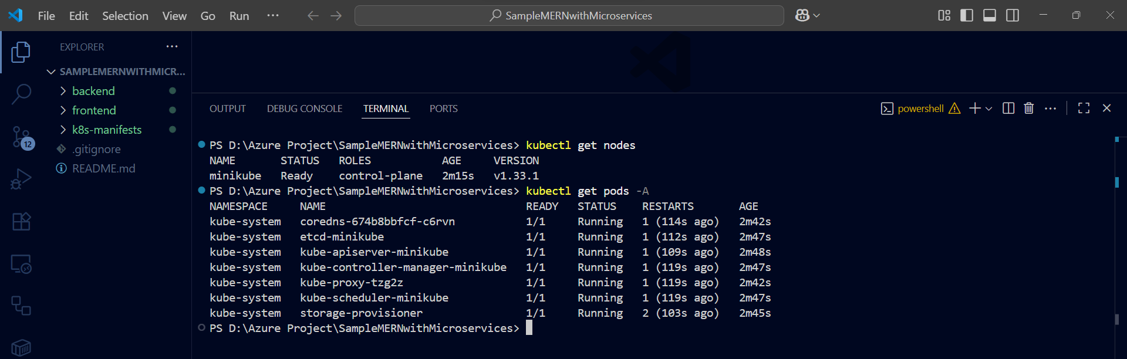

**Apply your app manifests:**

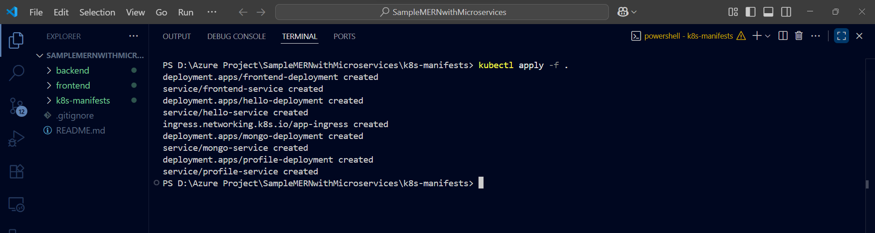

**Access the frontend in Minikube:**

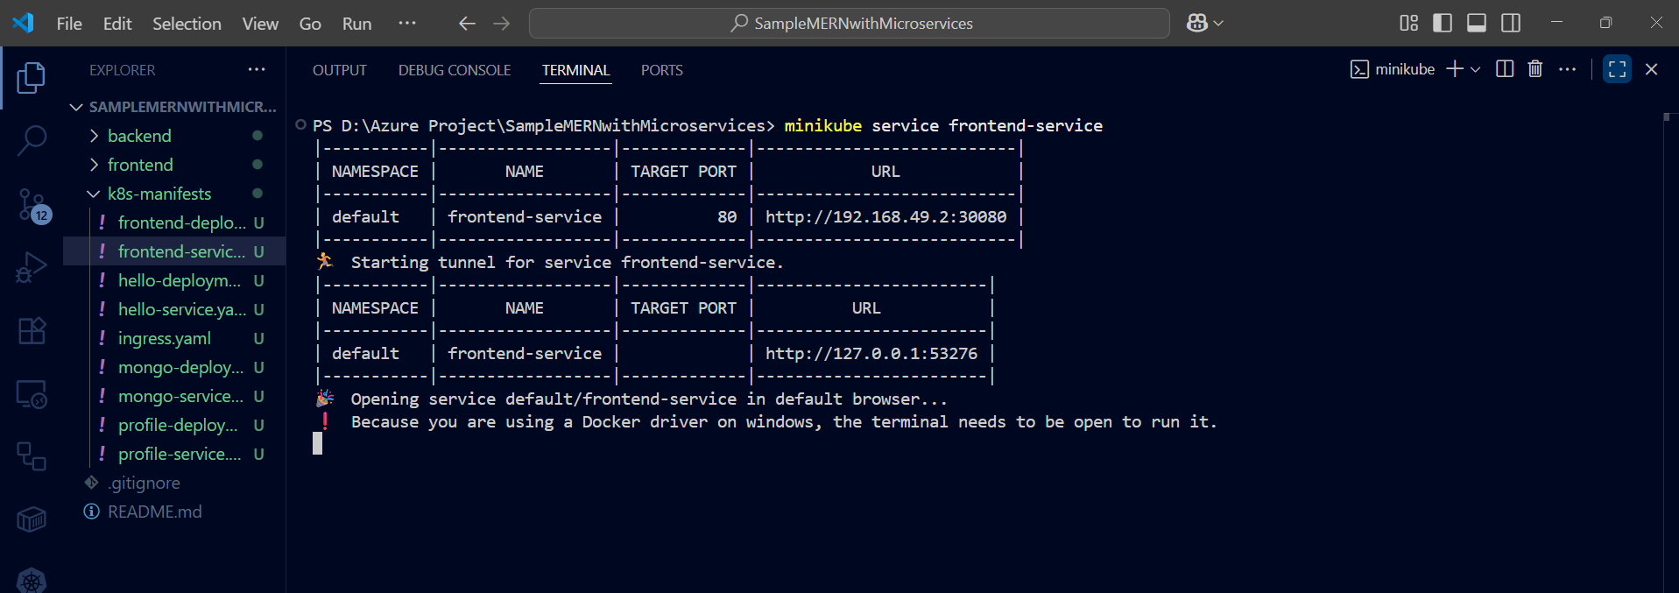

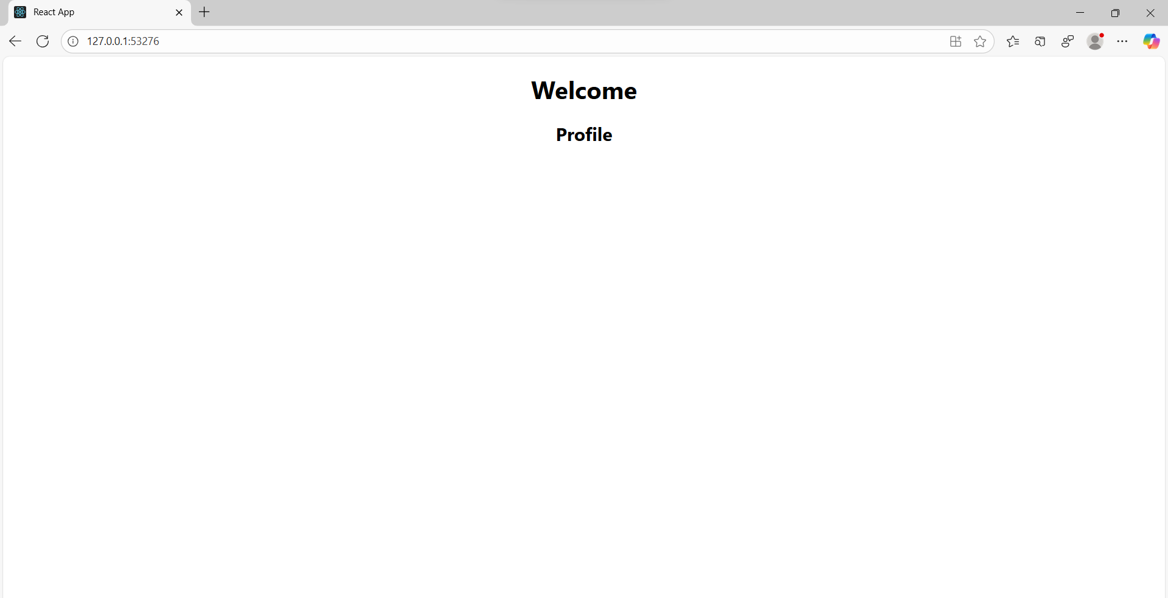

**Step 1: Evidence / Screenshots:**

**Pods status:**

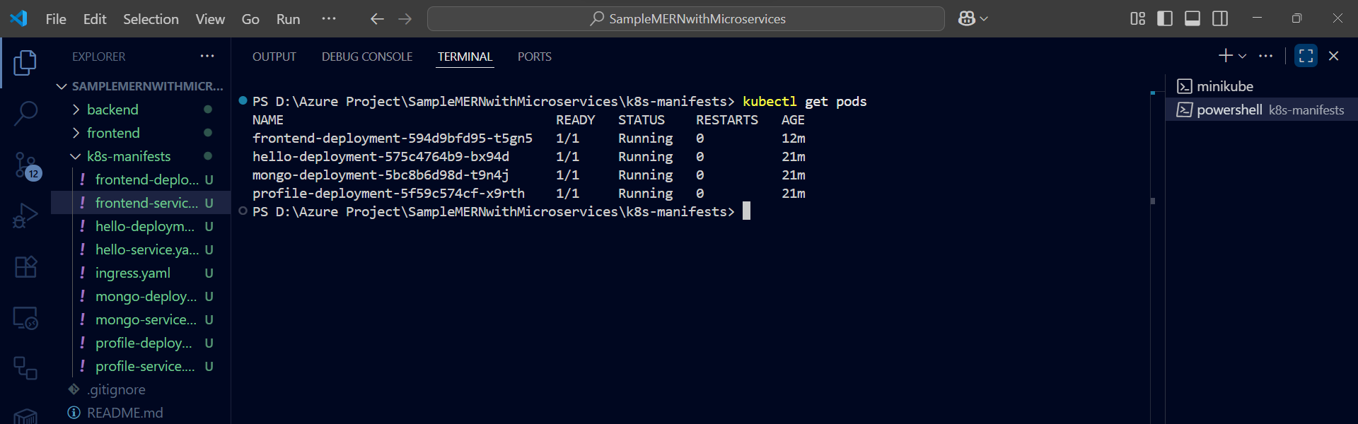

**Services status:**

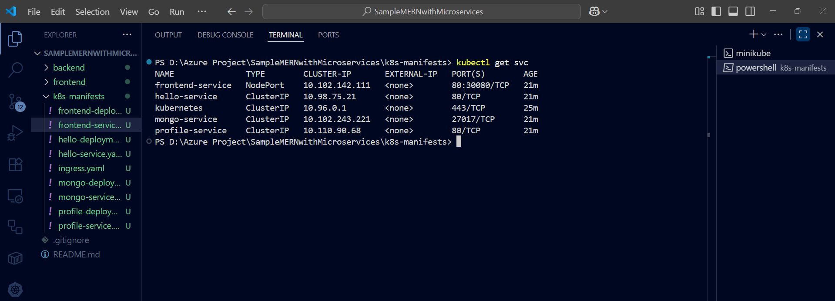

**Step 2: Push your manifests to GitHub:**

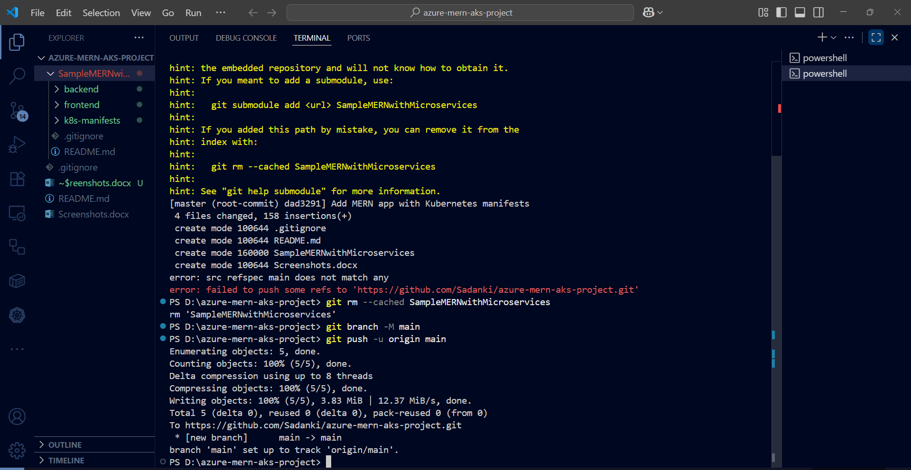

**Next Steps in Cloud Shell:**

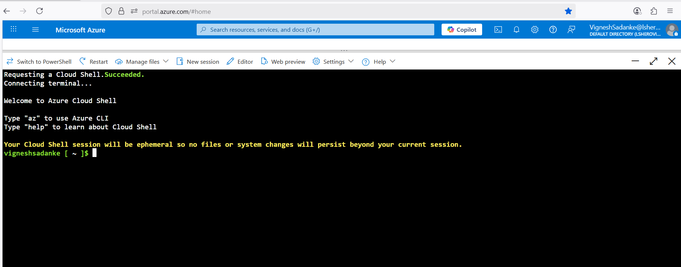

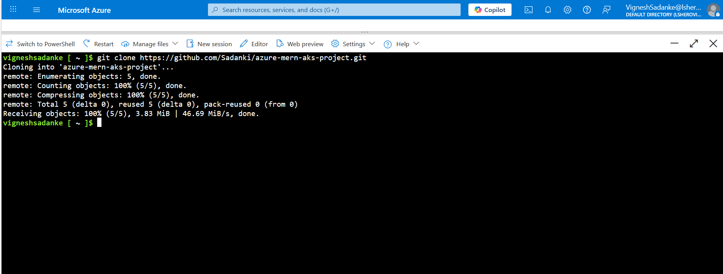

**Check existing resource groups (to see if you have permission to deploy AKS)**

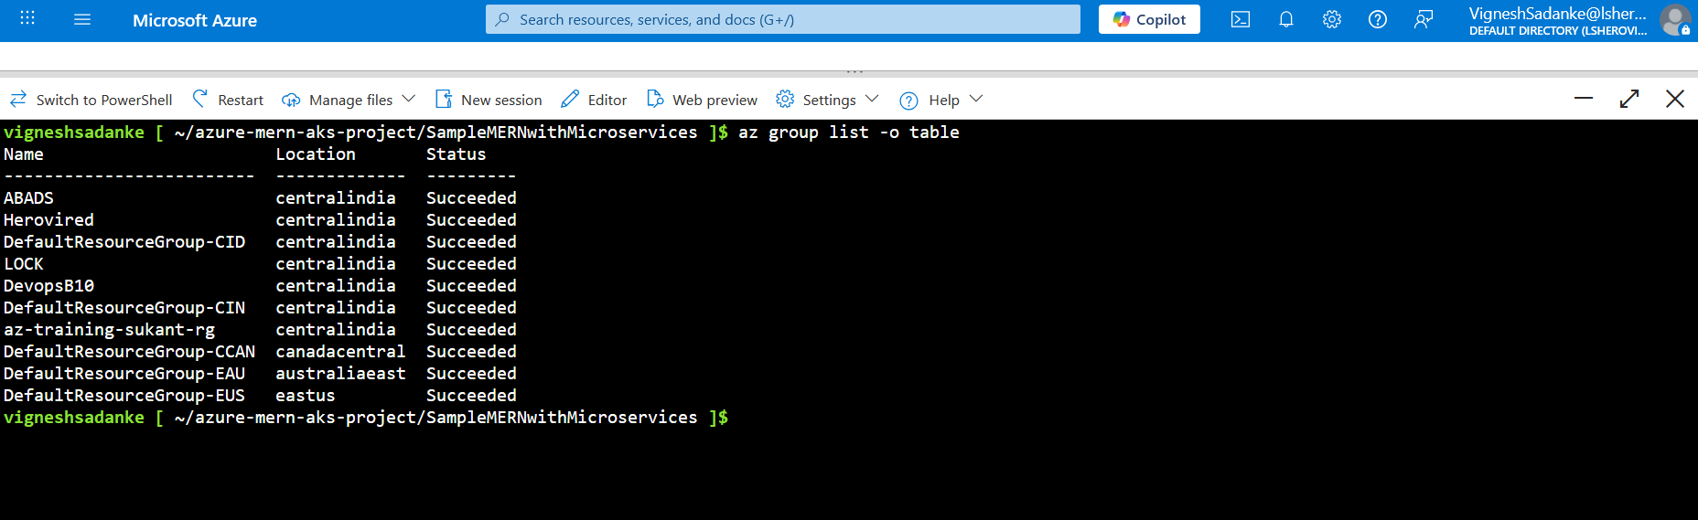

**Create Kubernetes cluster**

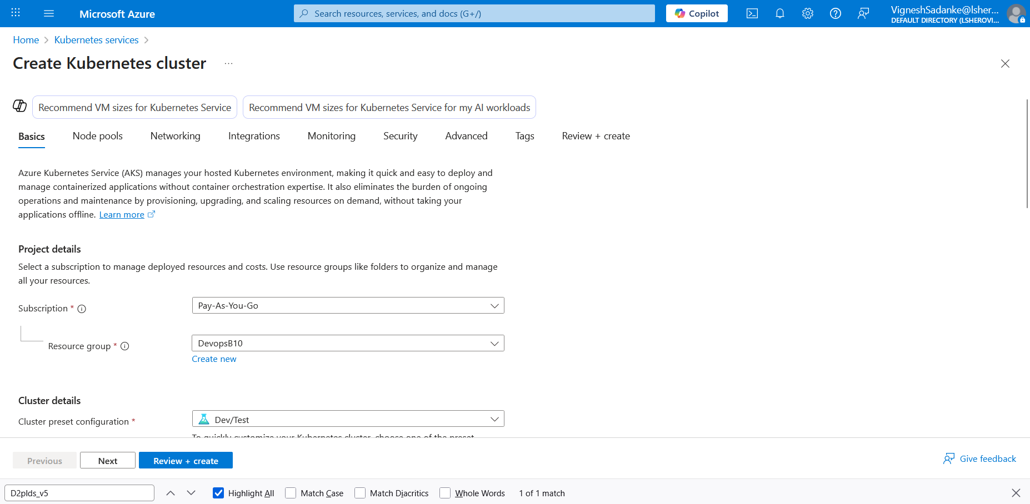

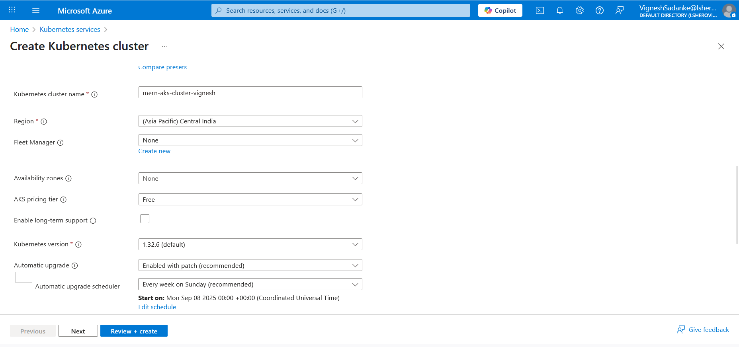

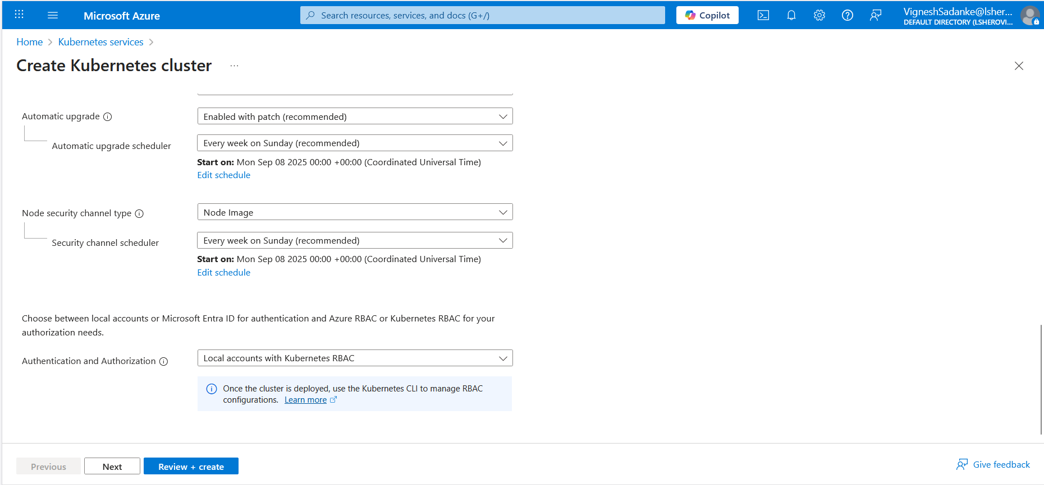

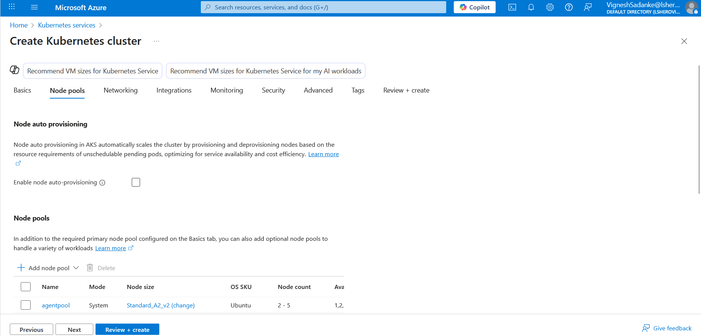

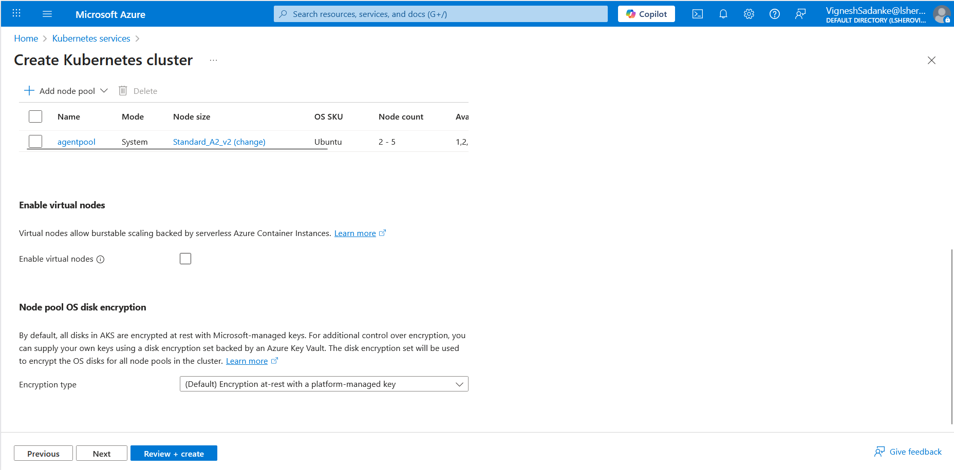

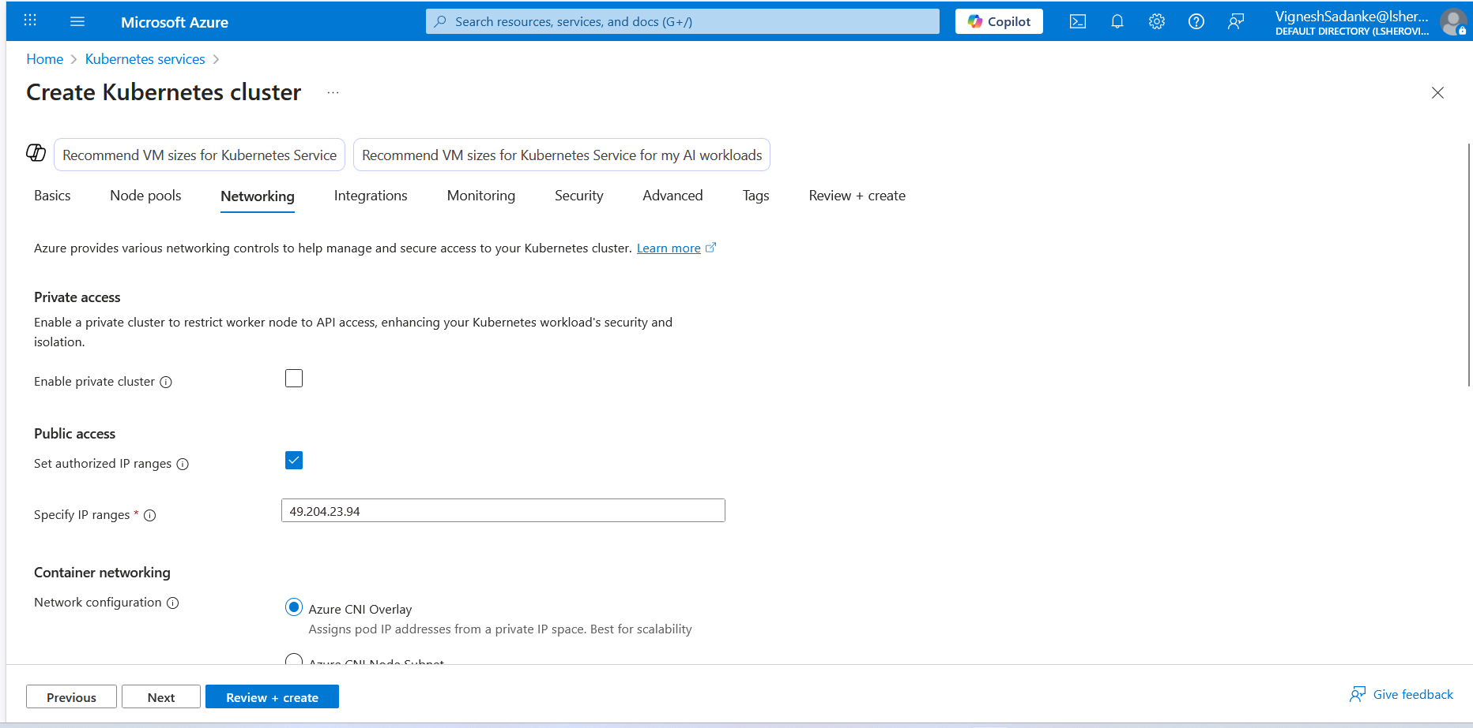

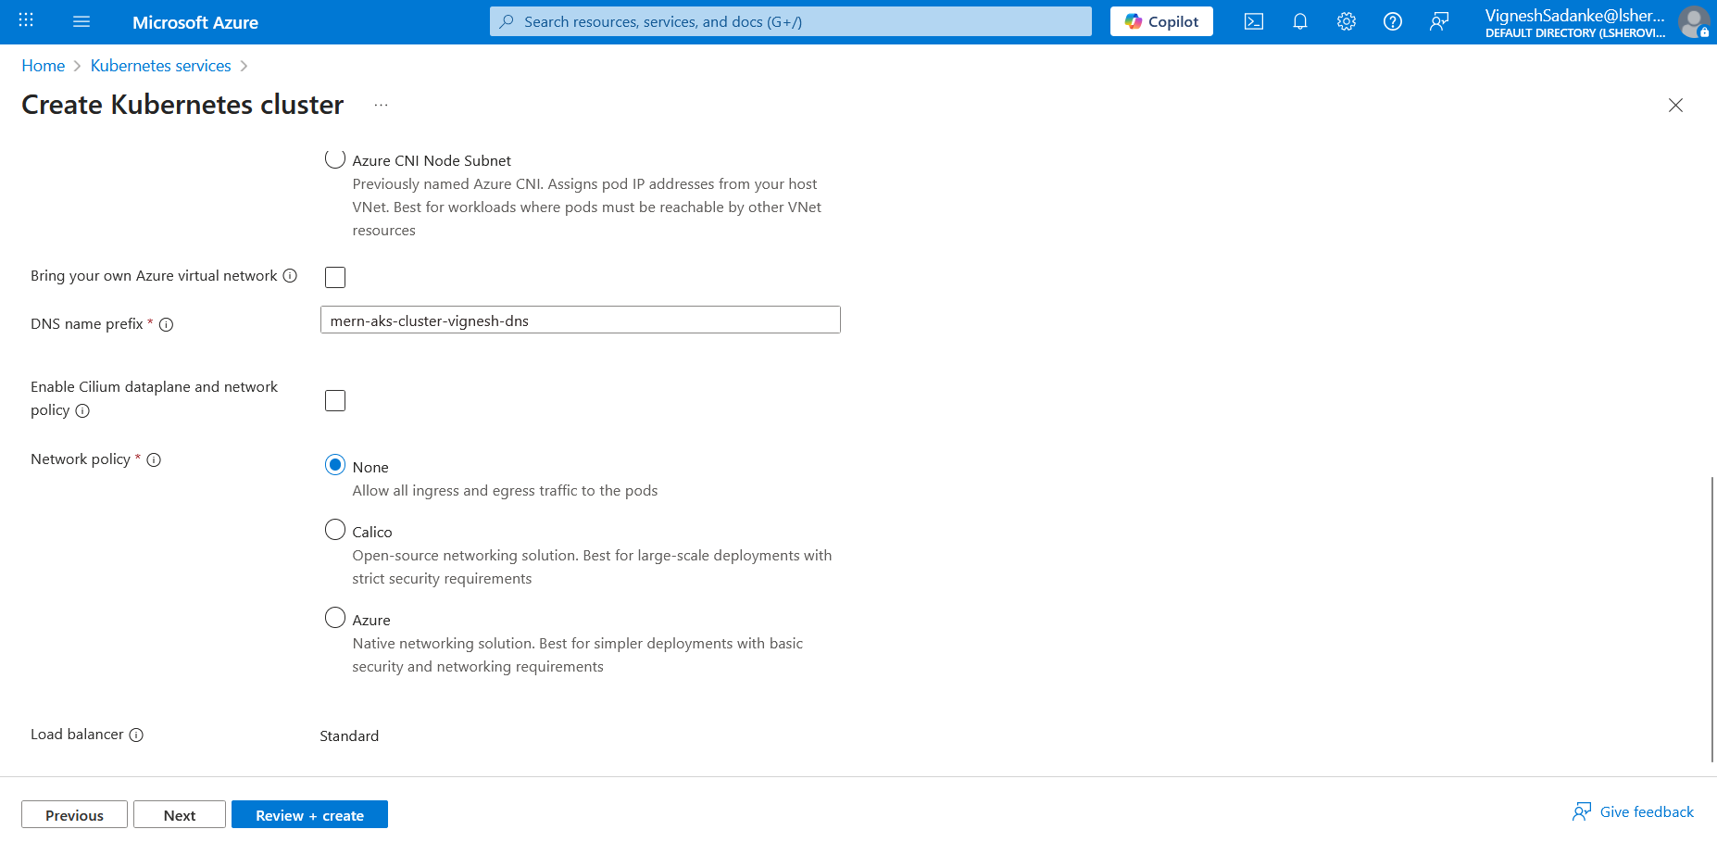

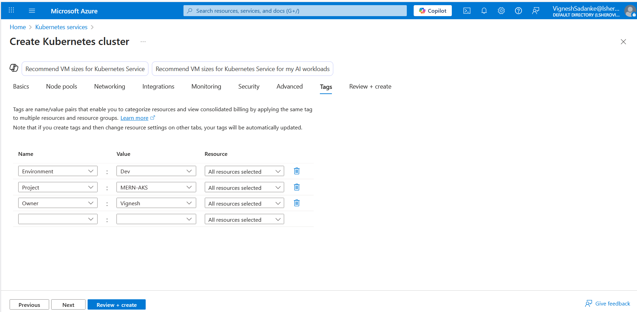

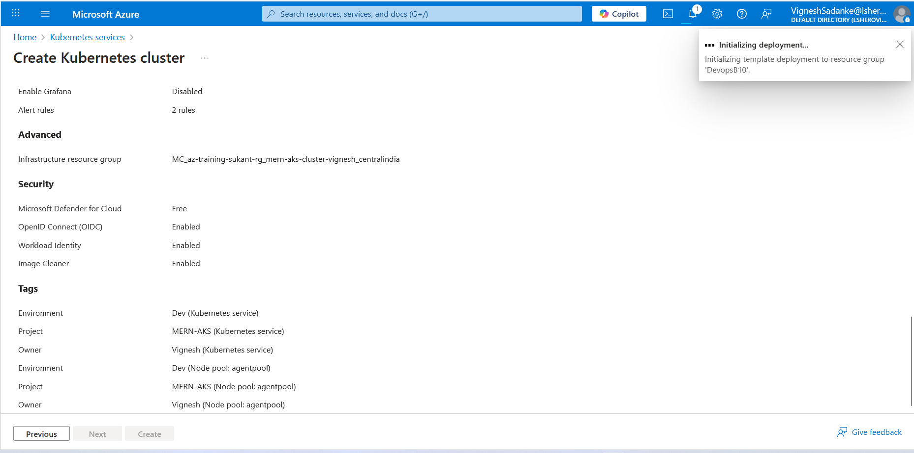

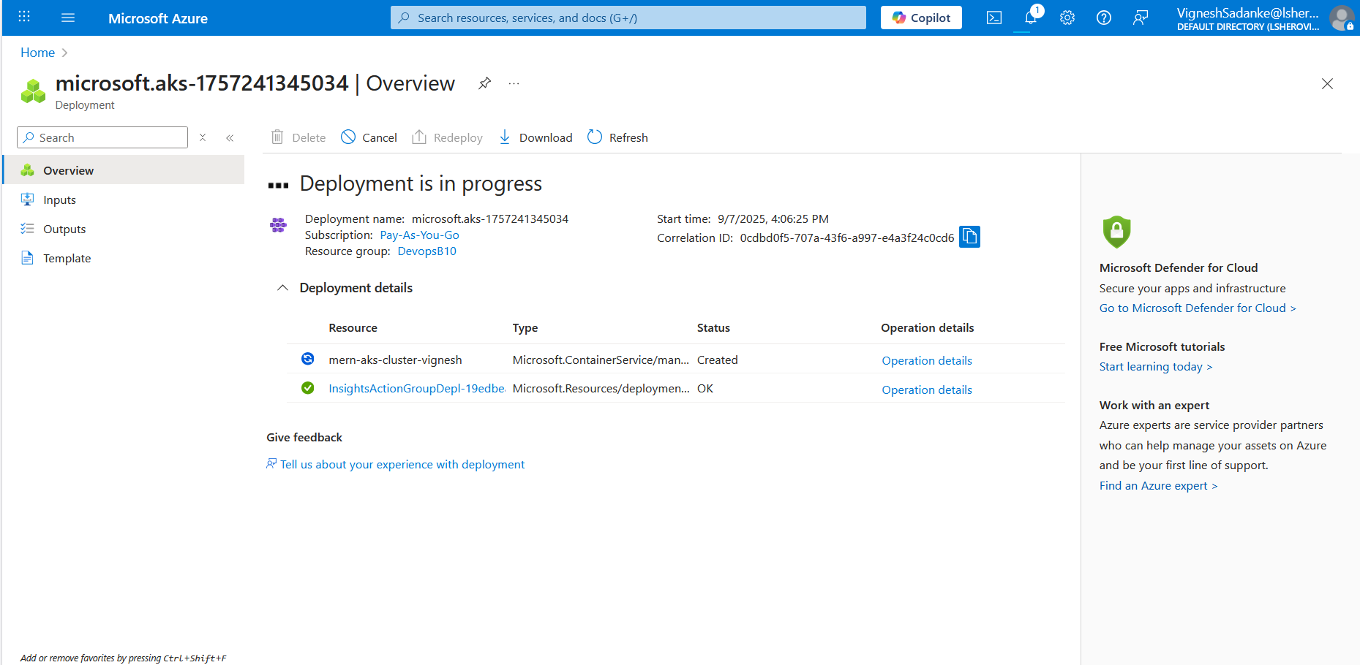

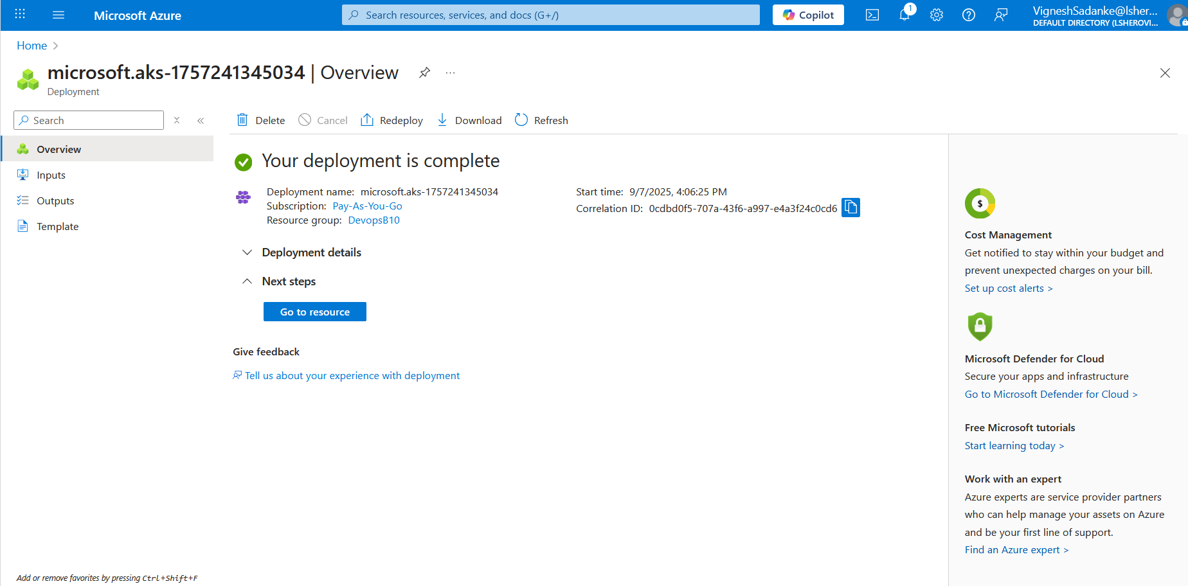

**Step 1: Connect to Your Cluster**

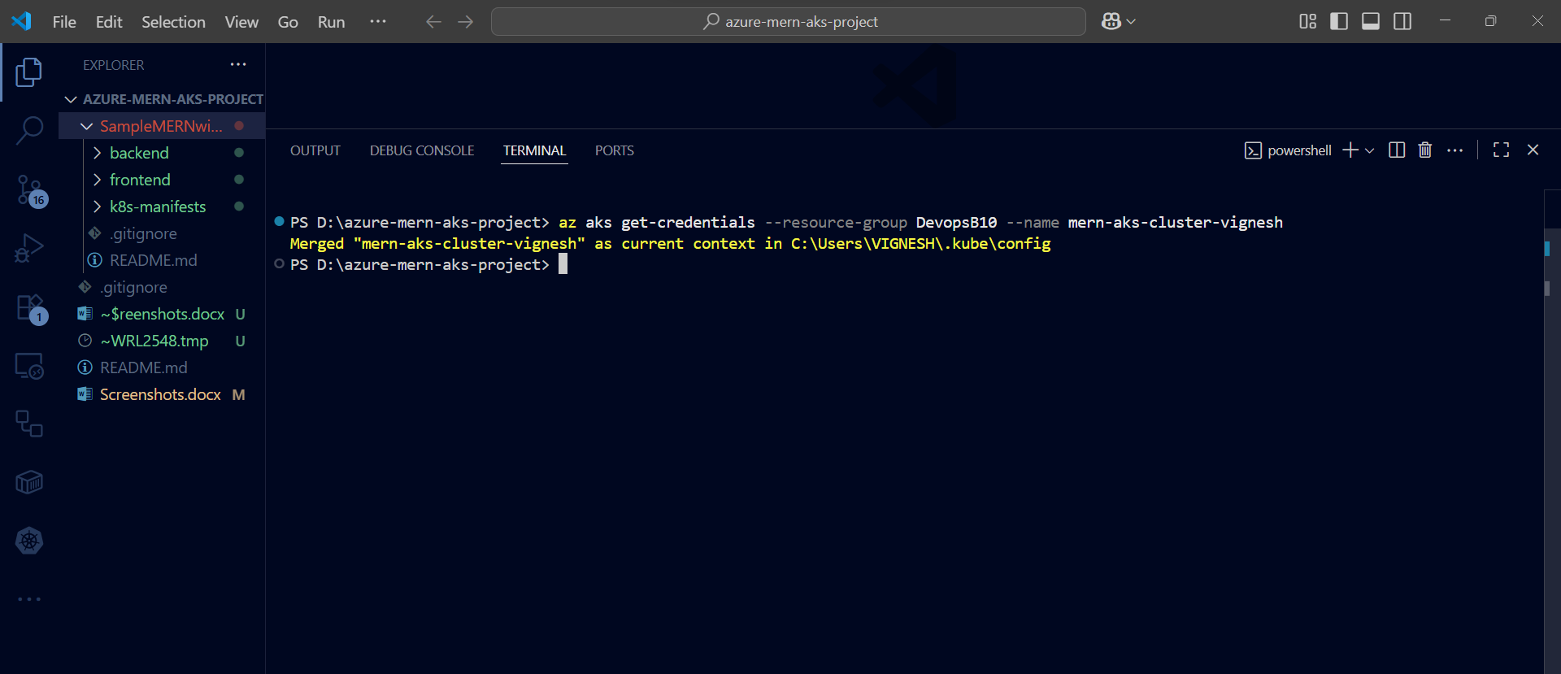

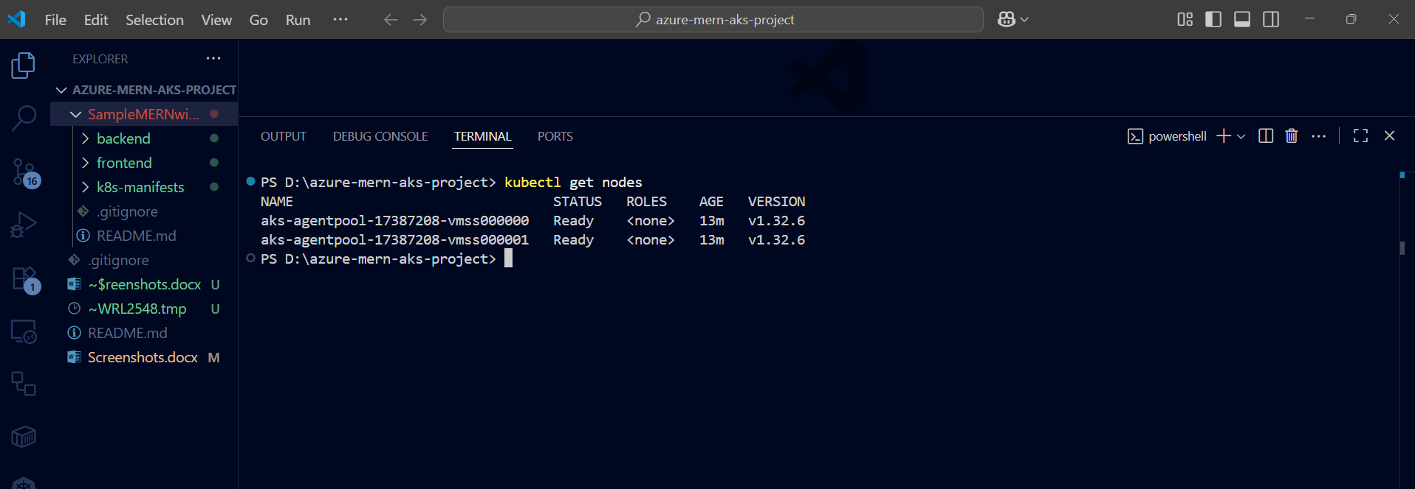

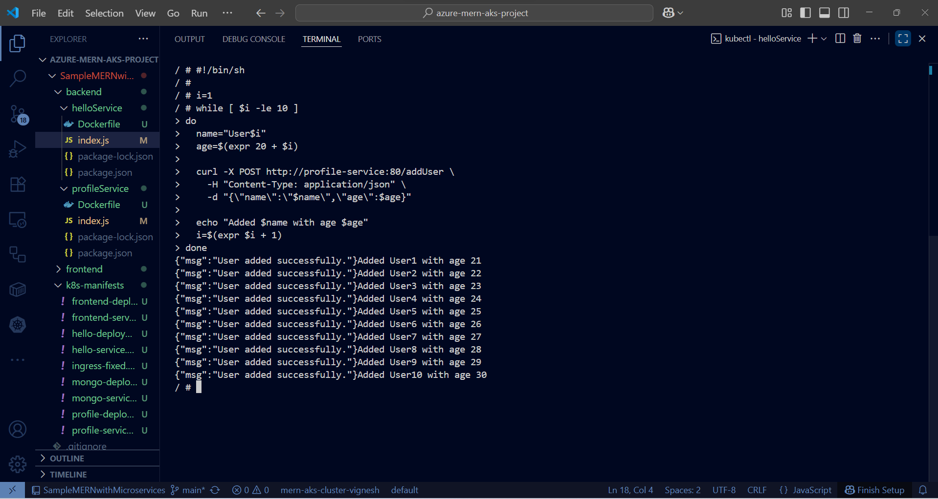

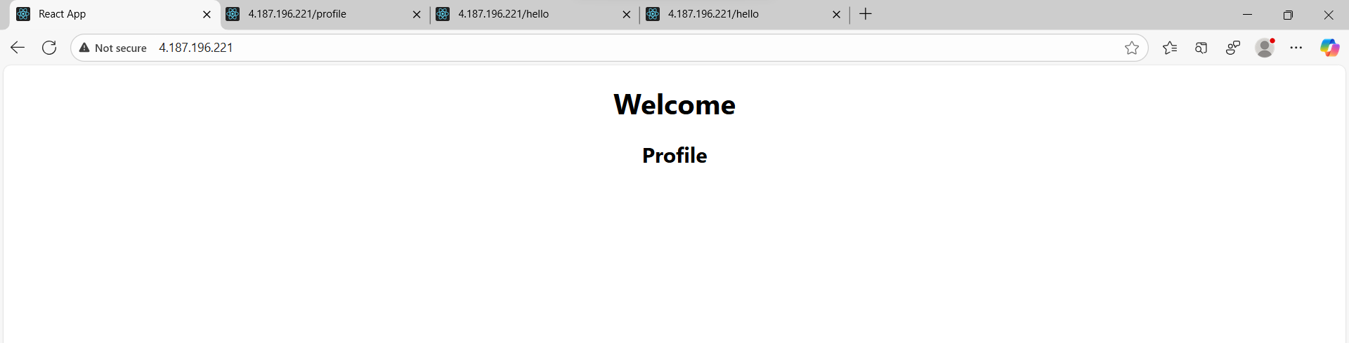

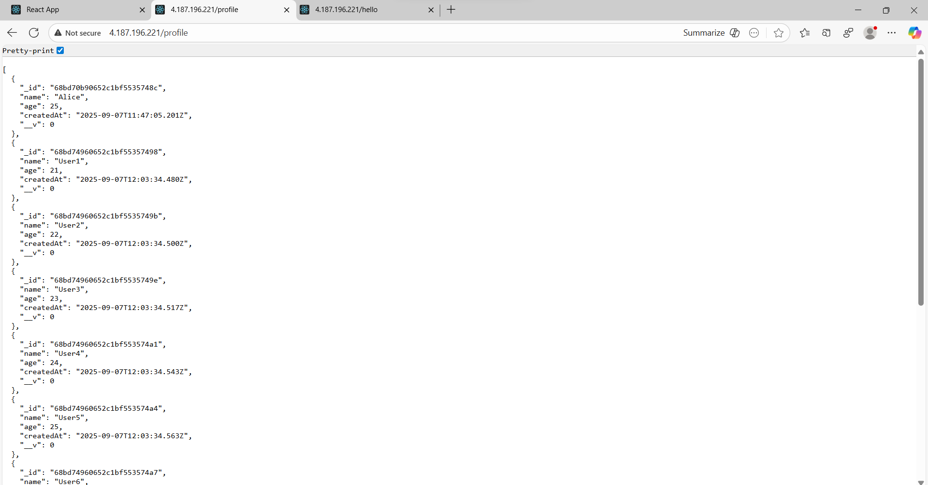

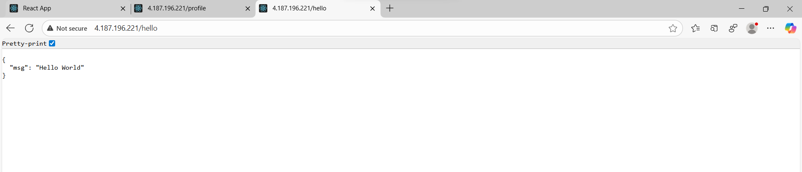

**Verify in Mongo:**

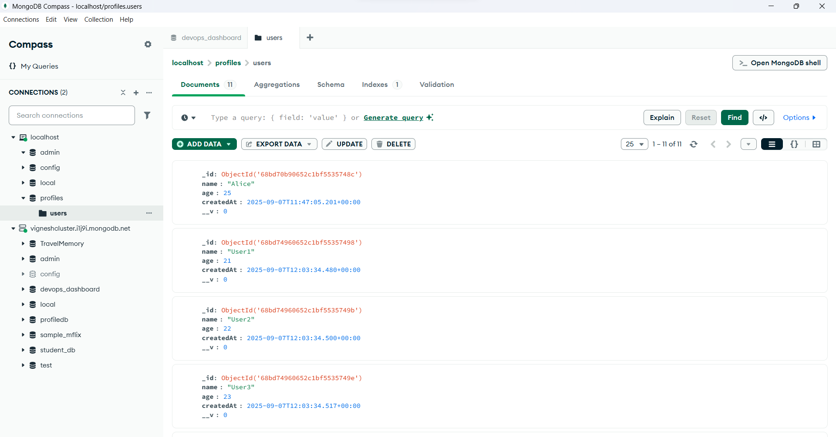

**Show all pods in all namespaces:**

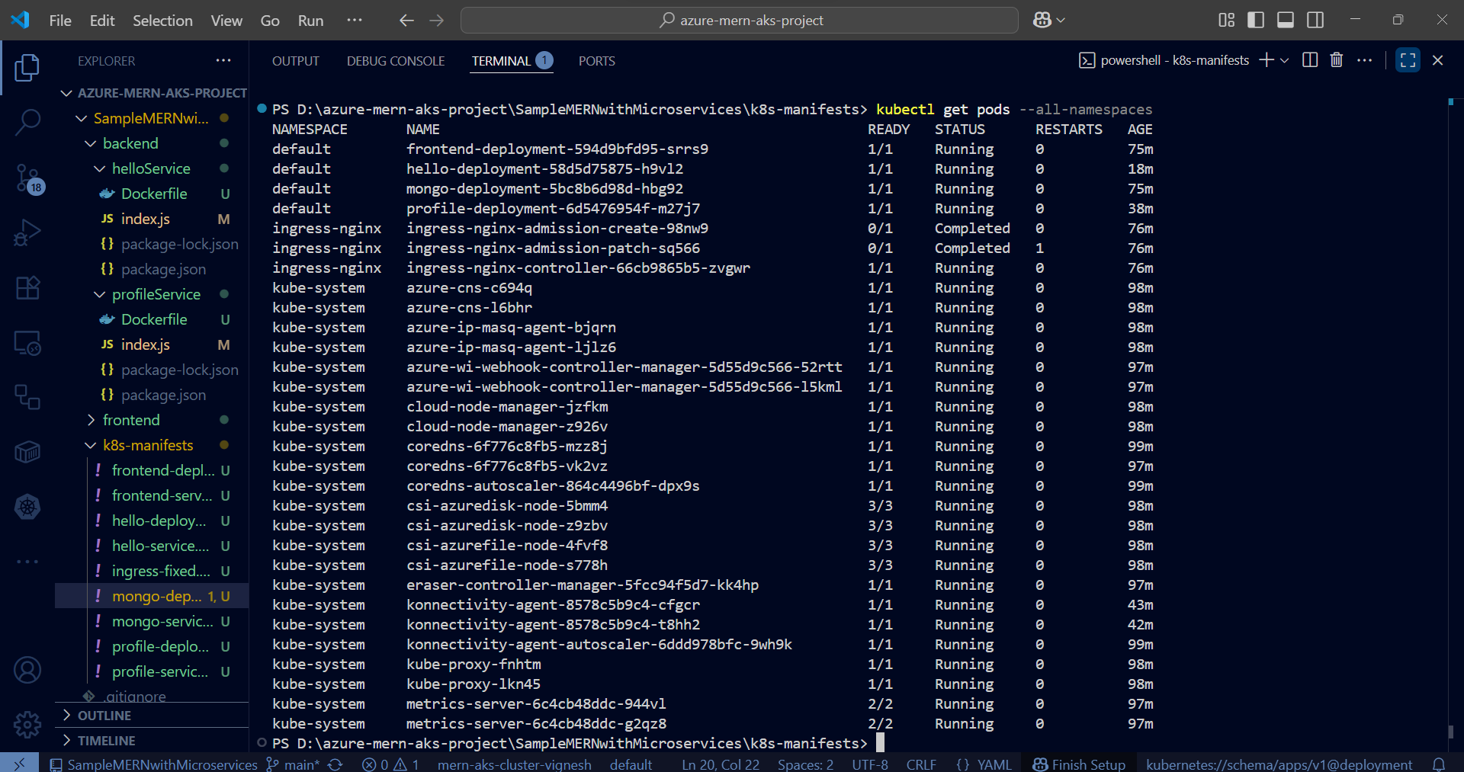

**Show all services in all namespaces:**

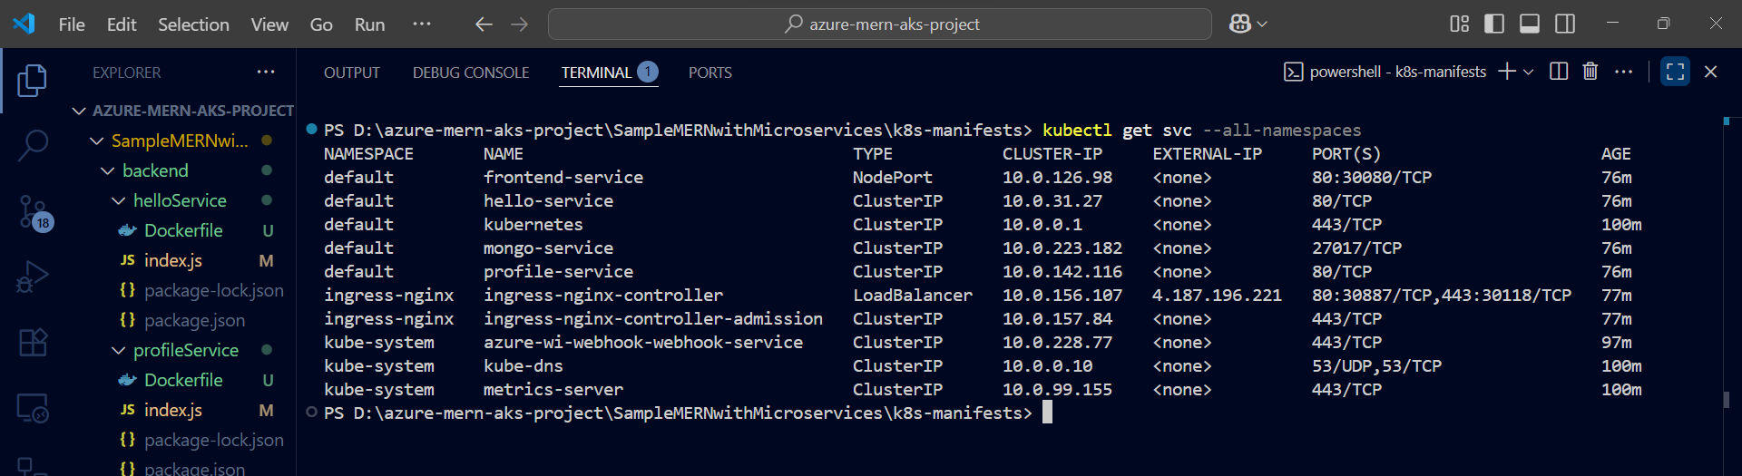

**Show all deployments in all namespaces:**

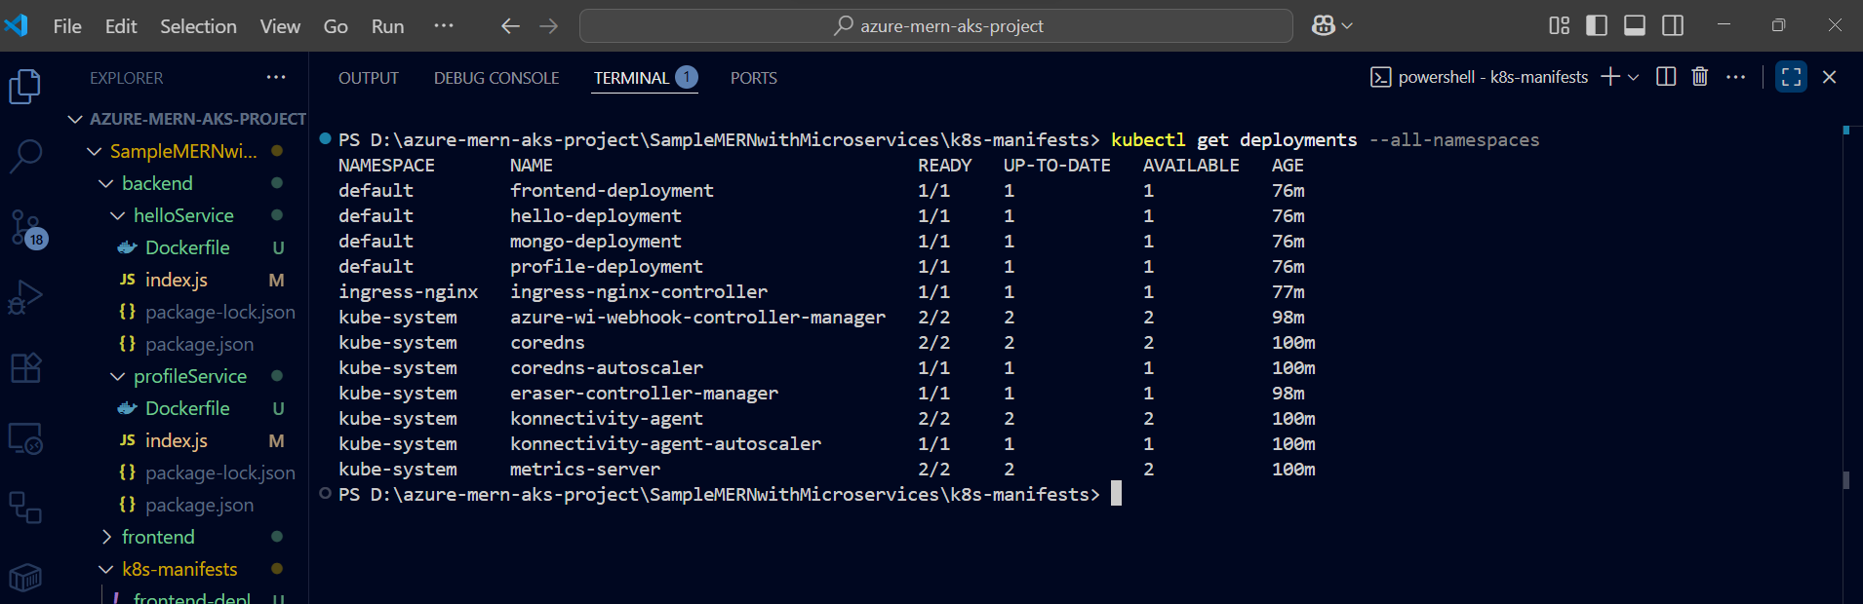

**kubectl get all:**

